STUDENT’S NAME: **MONDAY ALEXANDER ABEL**

STUDENT’S ID NUMBER: **77161472**

TUTOR: **MDM. MANIMALA**

**TASK 1: Implement Tables with suitable Data. Views.**

Tables implemented:

1. Department
2. Region
3. City
4. Officer
5. Crime
6. Offender
7. Crimes_committed

**Table 1: DEPARTMENT**

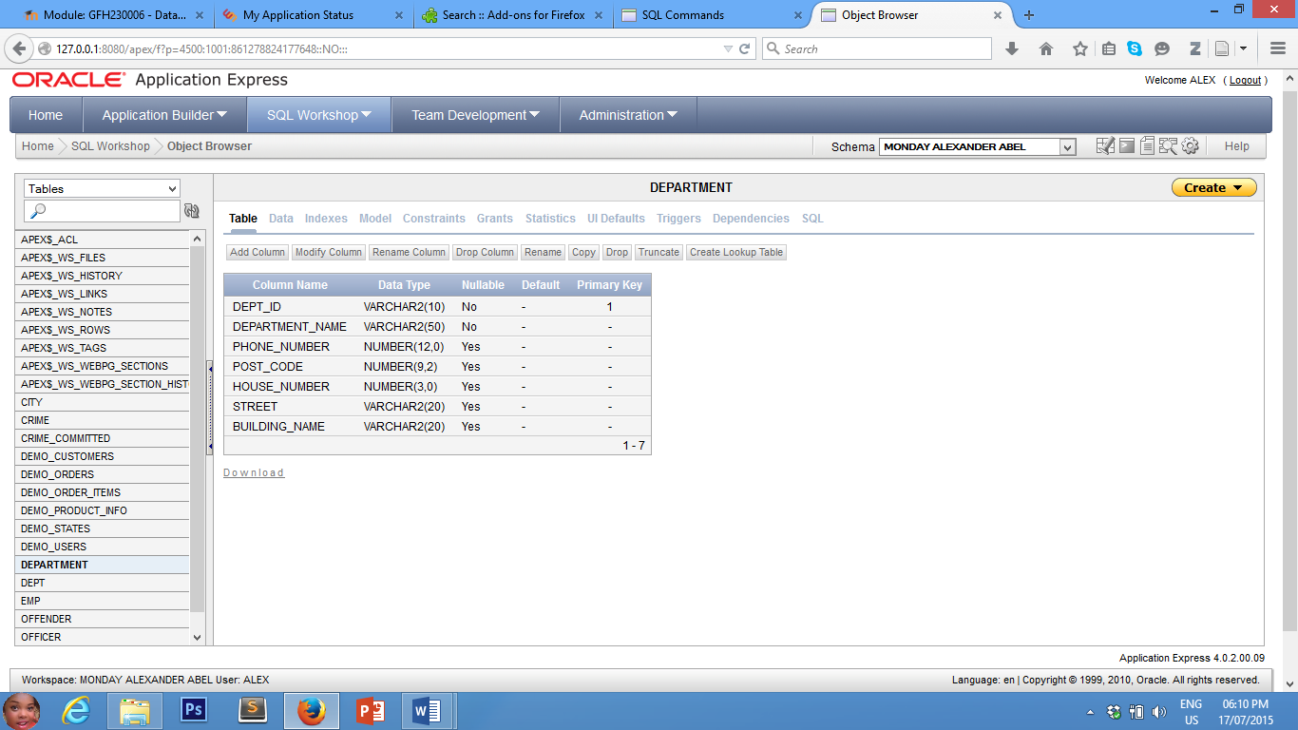

The department table contain details of the various Police Departments of England and Wales. The table has one primary key (dept_id). The datatypes have been carefully chosen to accommodate the expected input. The primary key column will be the initials of the department names combined with serial numbering pattern.

The Department_name and Dept_ID columns are mandatory, all other columns are optional.

**Table 2: REGION**

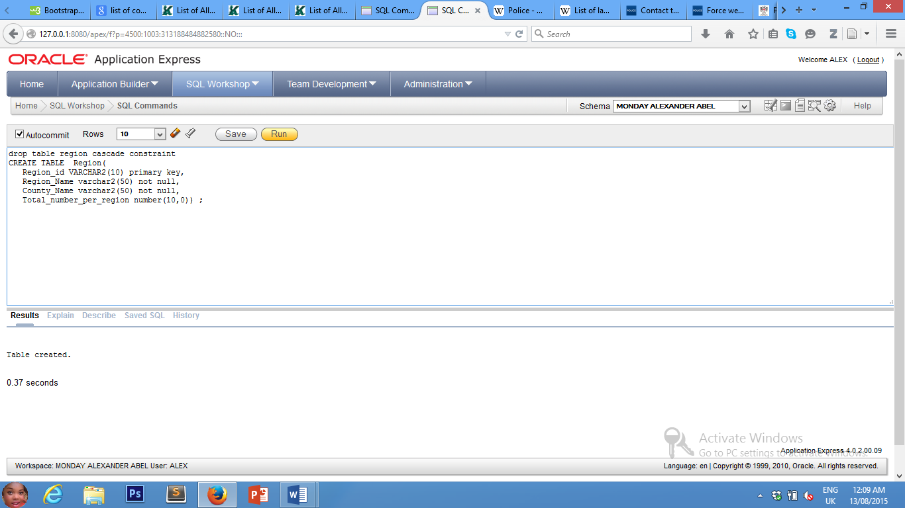

The Region table has Region_id as its primary key. The table had four (4) relevant attributes. Datatypes and sizes have been carefully chosen for appropriate data entry. The PK column of the Region table shall be based on the initials of the region names combined with numerals.

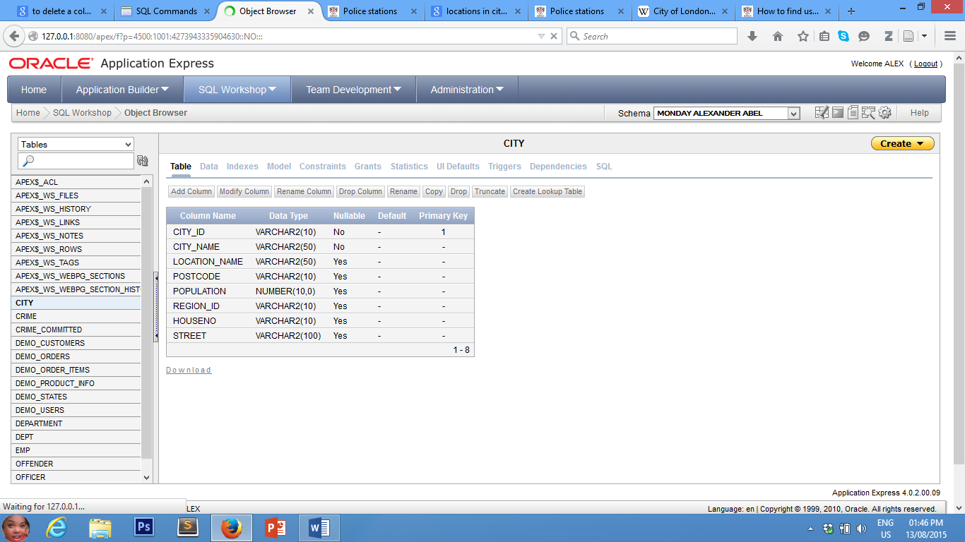**Table 3: City**

The City table is well planned with City_ID as its primary key. All columns have suitable datatypes and sizes relevant for the City table. The sequence of the PK column shall be the initials of the city names combined with serial numbers ranging from 001 – 999.

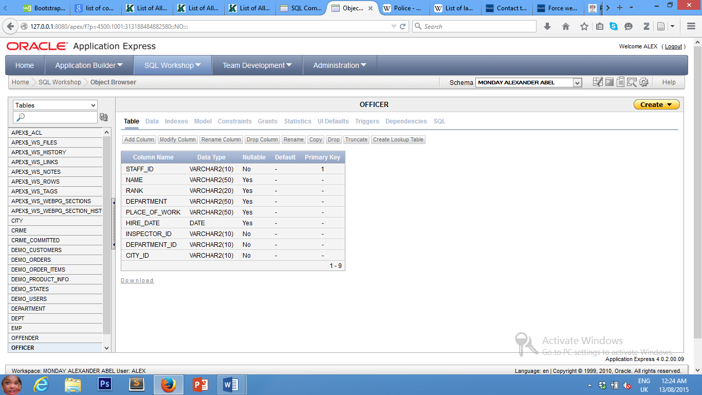**Table 4: OFFICER**

The Officer table has one PK column (staff_id). All the datatypes and sizes are suitable for the anticipated data entry. The PK column will have a serial numbering pattern (001 – 999).

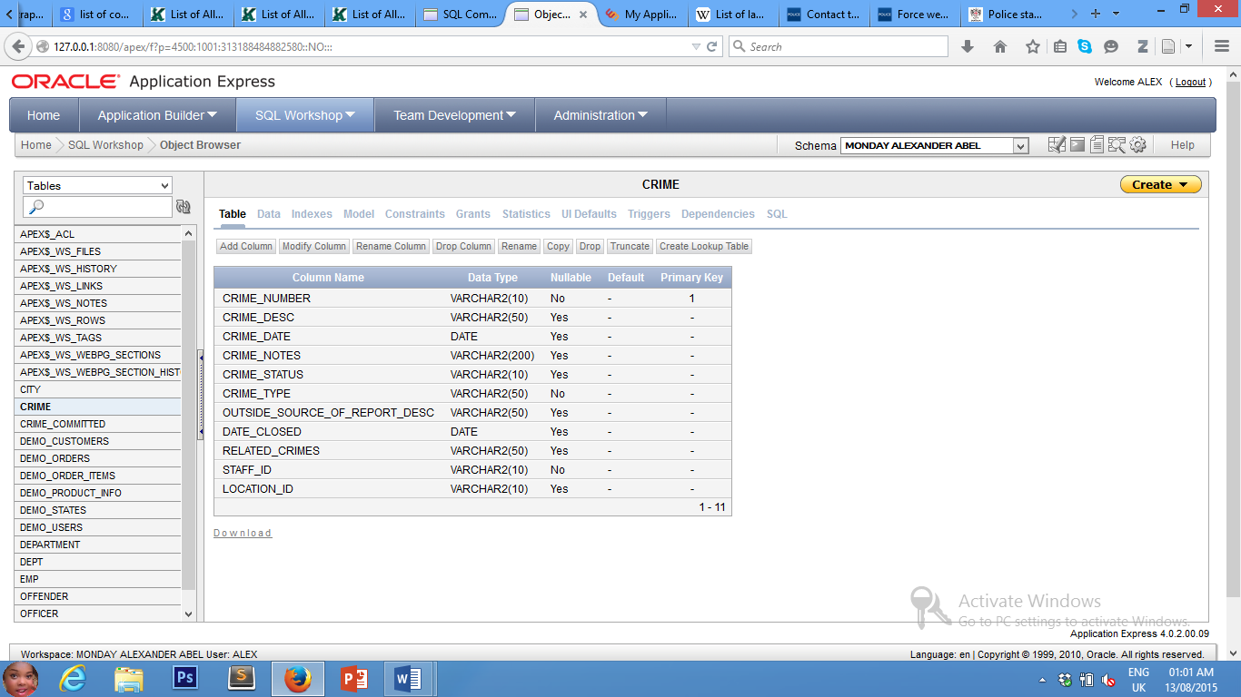**Table 5: CRIME**

The Crime table has 11 columns with its primary key column as crime_number. All the columns are carefully examined, and the datatypes and sizes carefully chosen to suit the data to be stored. The PK column will use a serial numbering pattern.

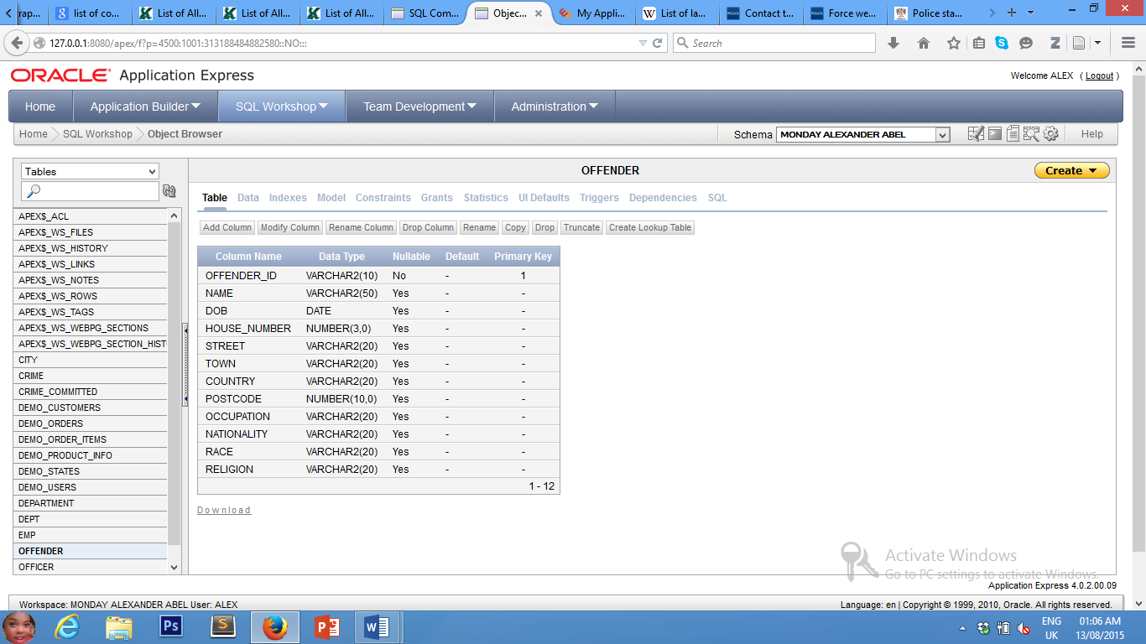**Table 6: OFFENDER**

The Offender table has 12 columns with its PK column as offender_id. Datatypes and sizes have been carefully chosen. Serial numbering pattern will also be adopted for the PK column.

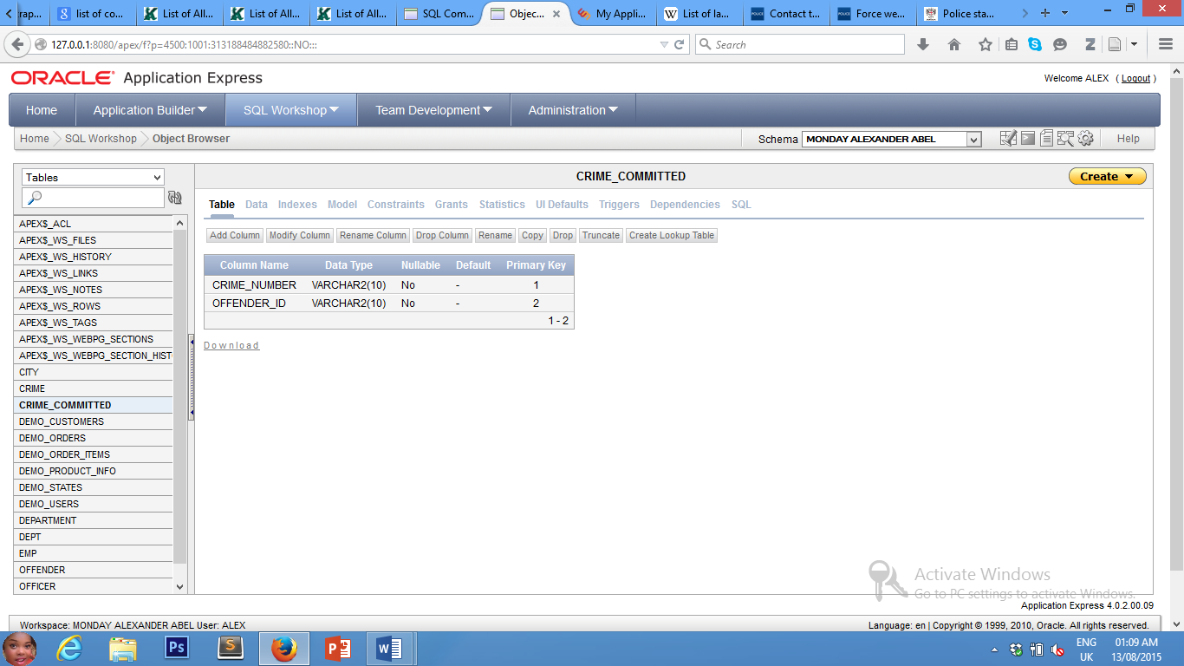**Table 7: CRIME_COMMITTED**

The Crime_committed has only 2 columns. This is because it is a link table between Crime and Offender tables. The 2 columns (which are foreign keys on this table), combine to form a compound primary key and will use exact data from their parent tables.

**DATA INSERTED**

**Table 1: DEPARTMENT**

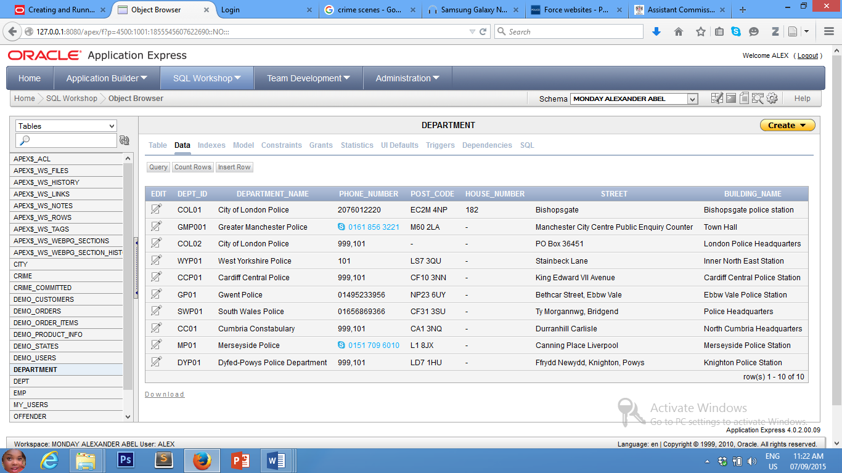

All the data for the Department table were carefully picked. They represent real facts of Police Departments in England and Wales. However, these data are only intended for this assignment purpose only.

**TABLE 2: REGION**

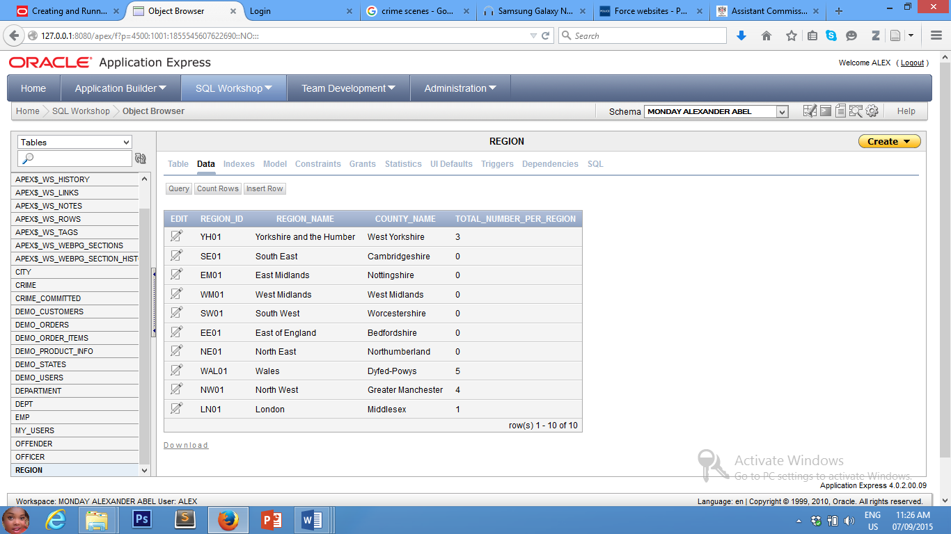

The Region Table holds data for all the regions in England and Wales. The counties were chosen at random from within the regions.

The Total_number_per_Region column is being calculated using a trigger. Once a new crime is inserted in the Crime table, this column will automatically be updated.

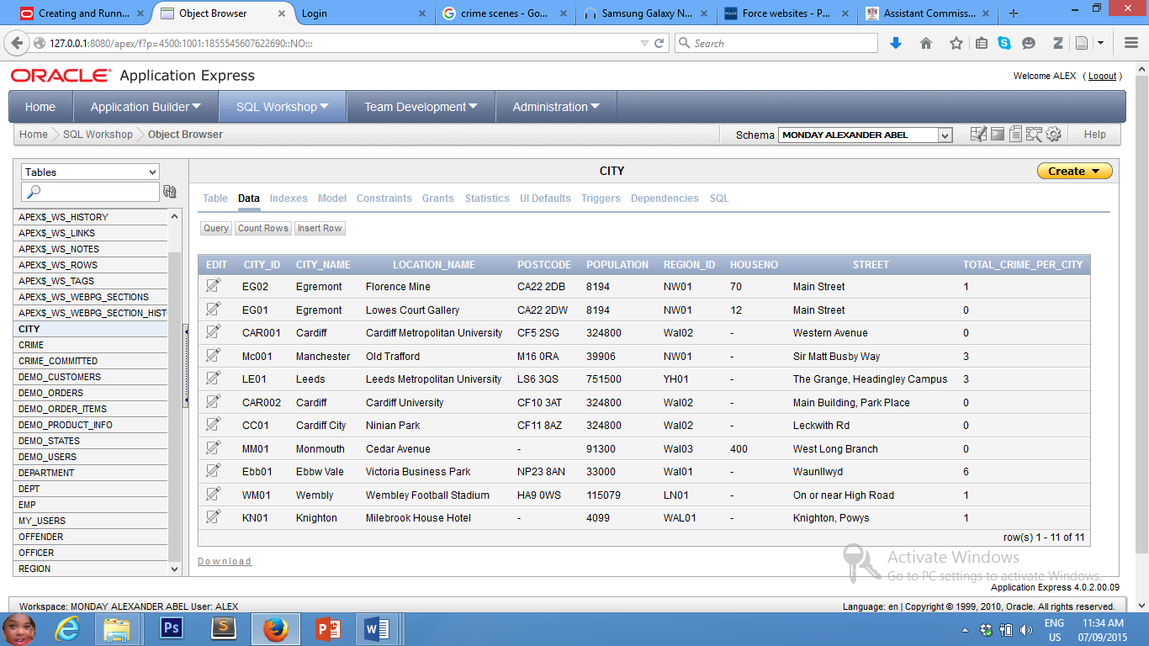**TABLE 3: CITY**

**Total_crime_per_city:** has been added to the city table. This column is borne because of its importance. This column is also calculated using trigger. Of what use will this application be if it cannot tell the City with the highest Crime rate?

All data are actual crime scenes in England and Wales (see reference).

**City_name:** stores the name of the city where the crime was recorded.

**Location_name:** is the location of the crime scene.

**Post_code:** is that of the city where the crime was recorded.

**Population:** is the population of the city as at 2014.

**Region_id:** is a FK column which depends on the Region table.

**House_no:** if the crime scene has one

**Street:** where the crime happened.

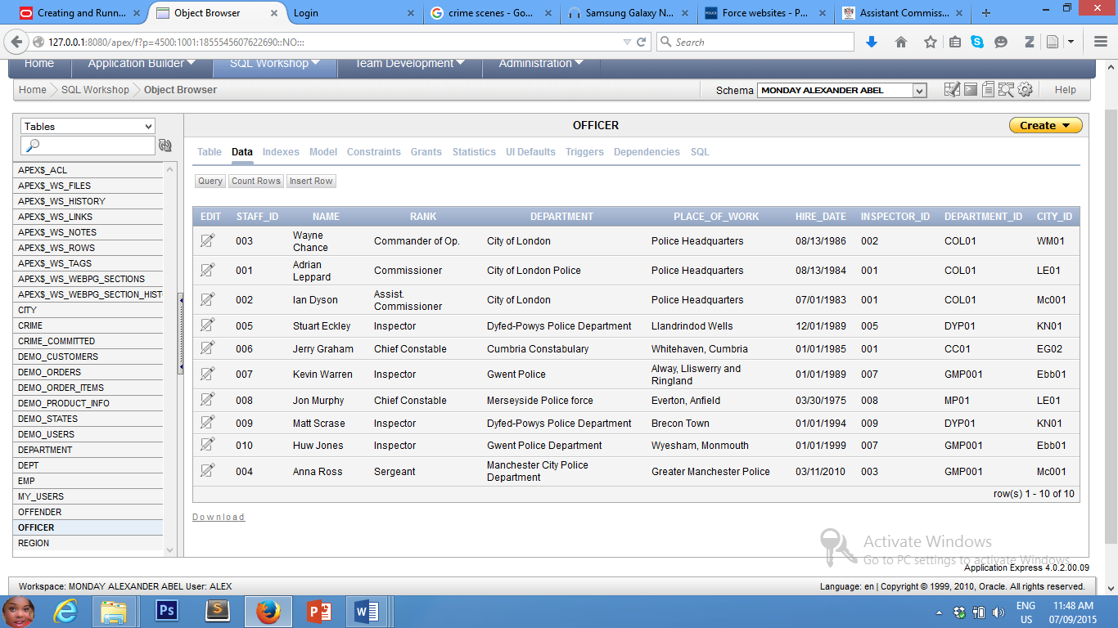**Table 4: OFFICER**

The Police officers who appear on this table are for assignment purposes only. They represent real police officers in England and Wales, their ranks and their place of work.

The table has three (3) FK columns viz:

**Inspector_id:** references staff_id on the same table (recursive relationship)

**Department_id:** references department.

**City_id:** references city.

**TABLE 5: CRIME**

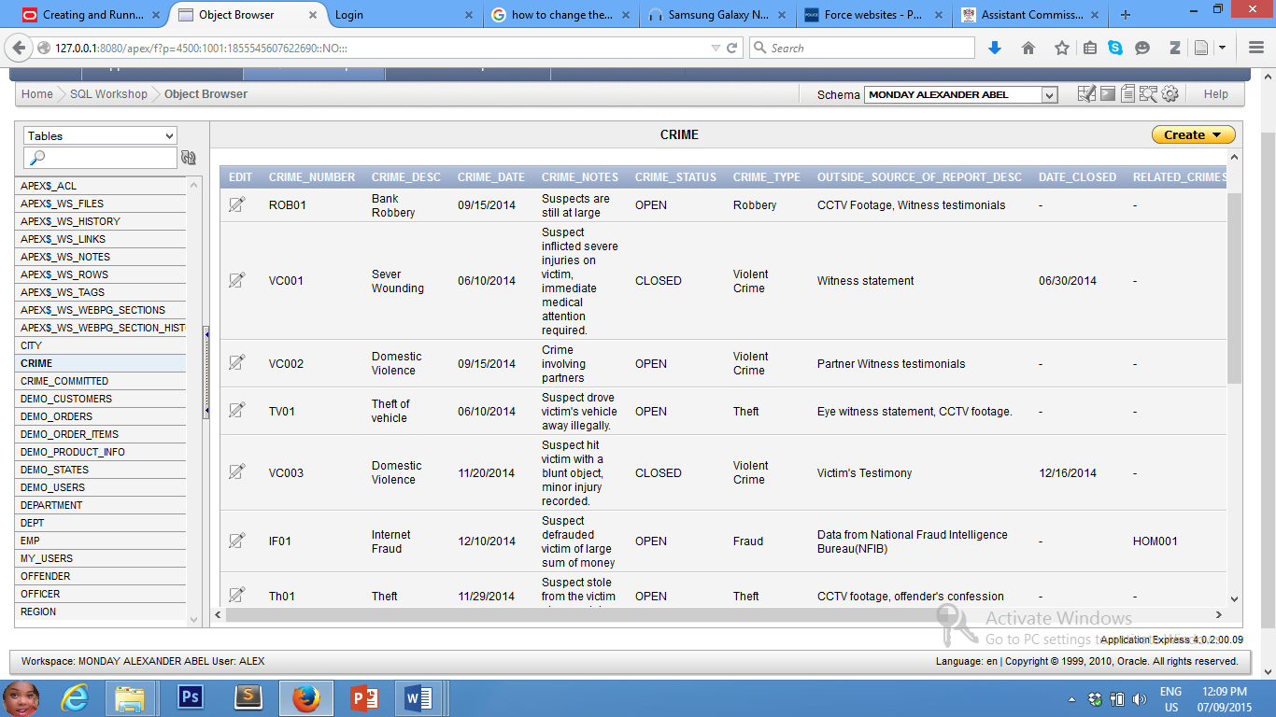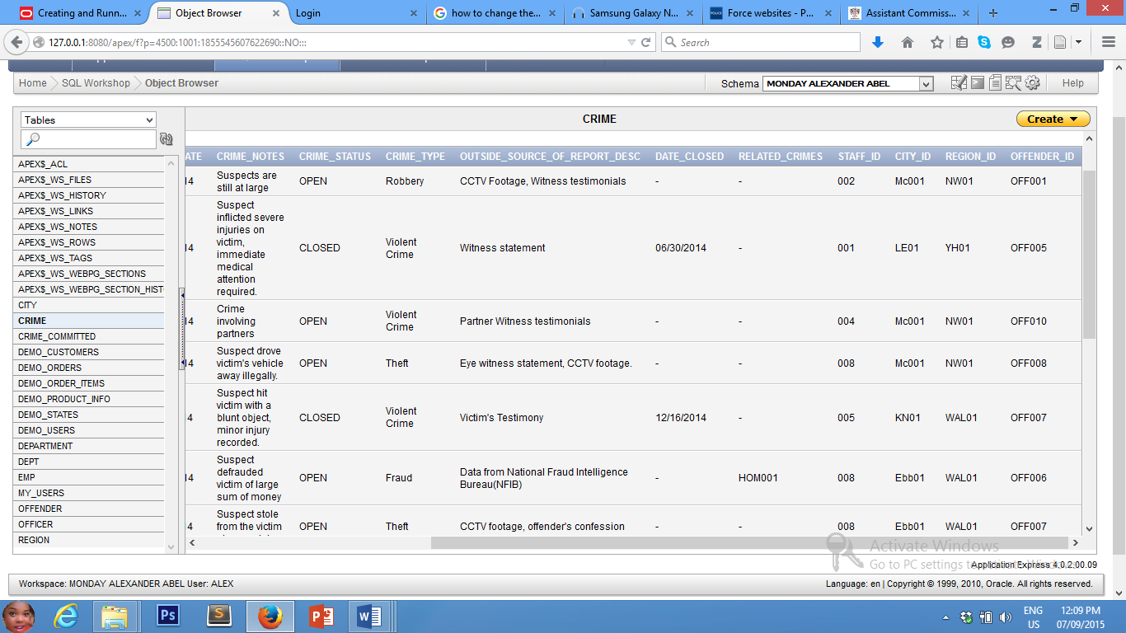

The crime table is about the most important table in my database application. Crime data are chosen at random with guide from real source (all references available on reference section).

The crime table references all other major tables in the application, viz:

**Related_crimes:** self- referencing (recursive relationship).

**Staff_id:** references Officer Table.

**City_id:** references City Table.

**Region_id:** references Region Table.

**Offender_id:** references Offender Table.

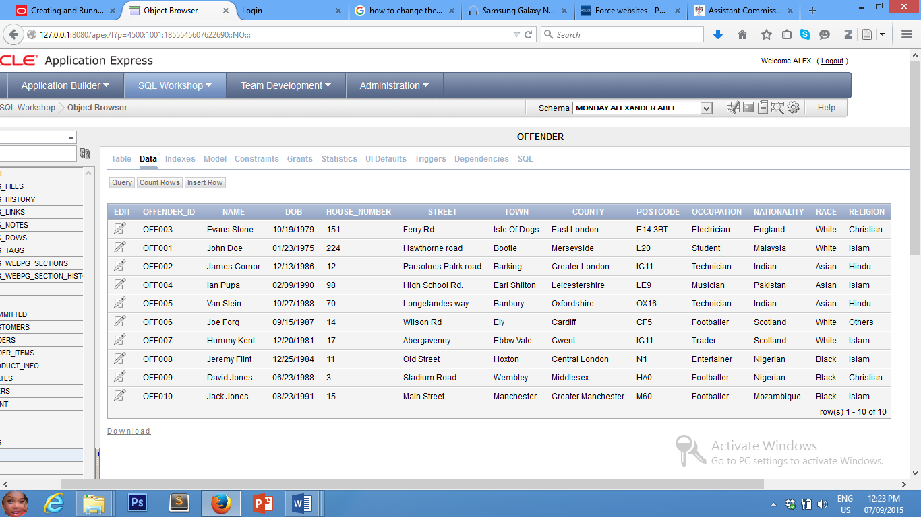**TABLE 6: OFFENDER**

The offender table holds information about the offenders of the recorded crimes. The data has been chosen randomly with proper guidance from actual sources.

Disclaimer: the data on this table is not intended to promote any form of racial or religious abuse. It is intended for this assignment only.

**TABLE 7: CRIME_COMMITTED**

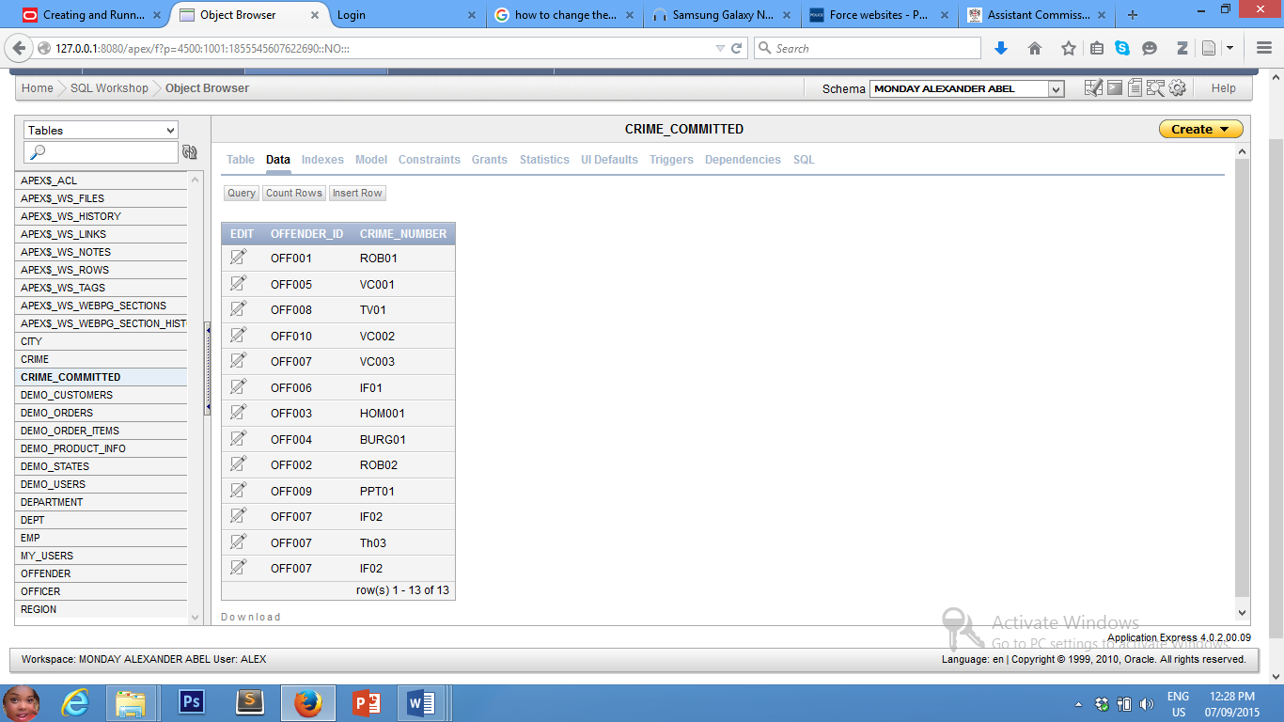

This table has been stream-lined to hold the foreign keys from offender and crime. Other columns are considered unnecessary (because the data already exist in the referenced tables). It references the Offender and Crime tables respectively.

Data are inserted into both columns automatically using triggers.

**CONSTRAINTS**

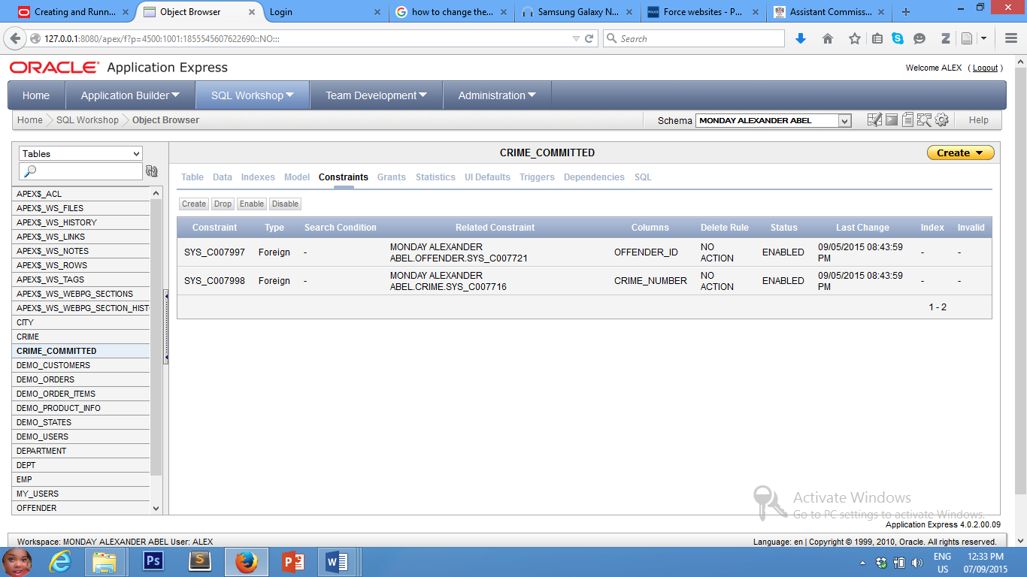

Two declarative constraints have been created. These were created into the Crime_committed table. They provide a reference link to the referenced tables, viz: Offender and Crime.

Other constraints have also been used.

1. Checked constraint is used on the crime_status on the Crime Table.
2. Triggers have also been used (will be explained in details later).

**VIEWS**

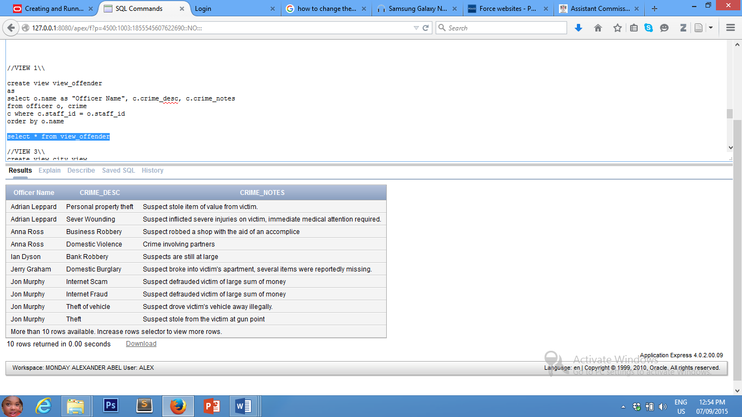**VIEW 1: VIEW_OFFENDER**

This view was created to show the offenders, their crimes and crime notes.

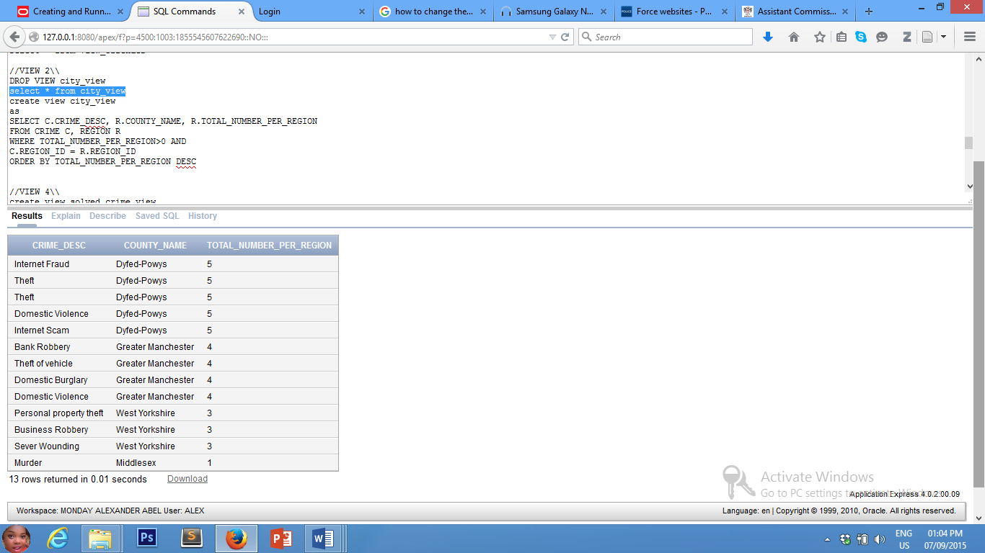**VIEW 2: CITY_VIEW**

View to show the region with the highest number of crimes.

**VIEW 3: SOLVED_CRIME_VIEW**

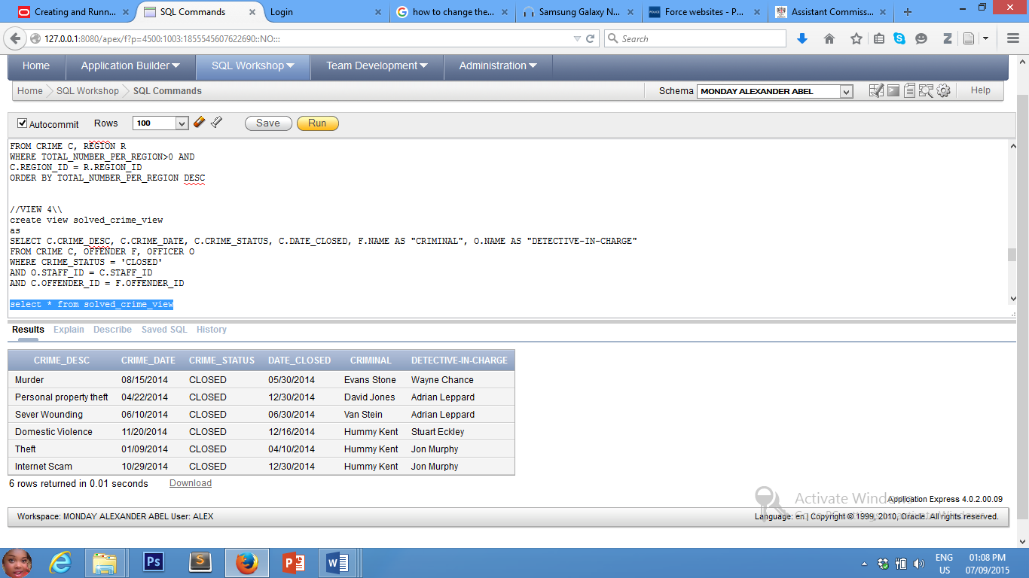

View to show closed crime.

**VIEW 4: PENDING_CRIME_VIEW**

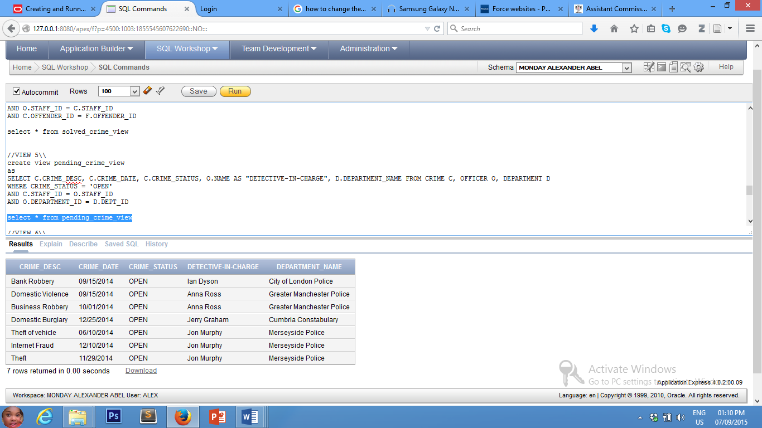

View to show pending crimes.

All the codes for these views and other views have been provided in the codes section.

**TASK 2:**

**DATA MANIPULATION LANGUAGE (DML) PAGES.**

**SCREEN 1: CRIME FORM**

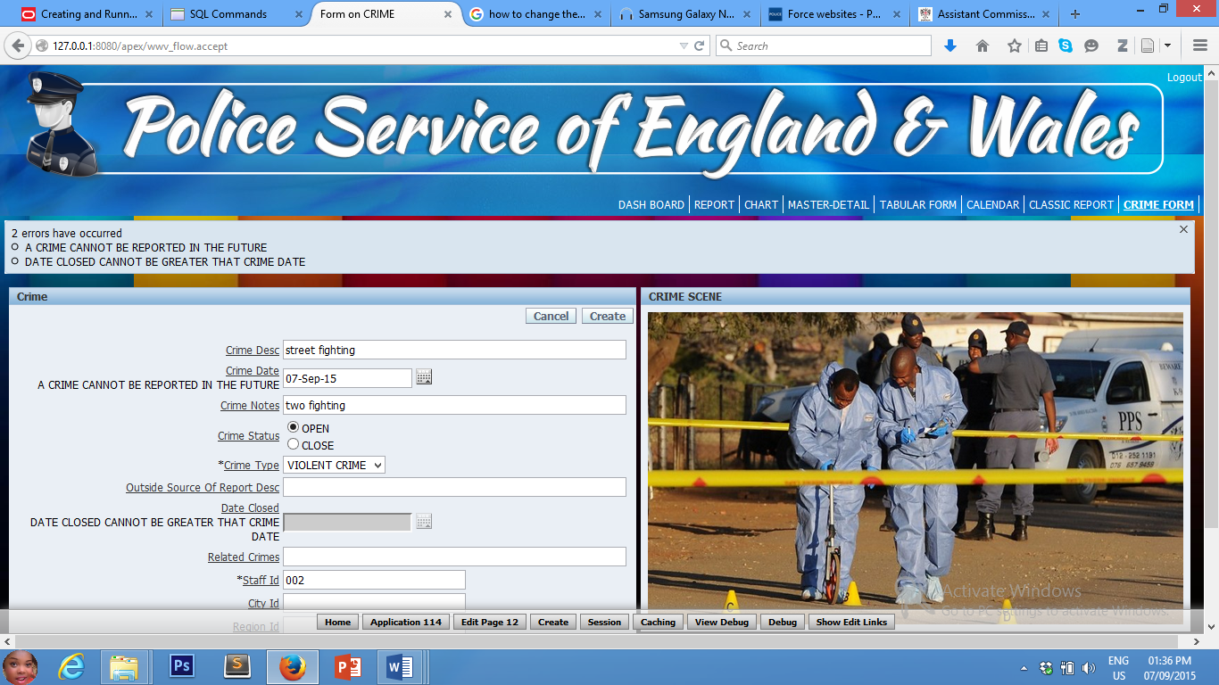

Validation

Validation

Disable

Dynamic LOV

Static LOV

The page has **static list of values** for crime status, **dynamic LOV** for crime type, **disable** for date closed and **validations** for crime date and date closed.

**SCREEN 2: INSERT (DEPARTMENT 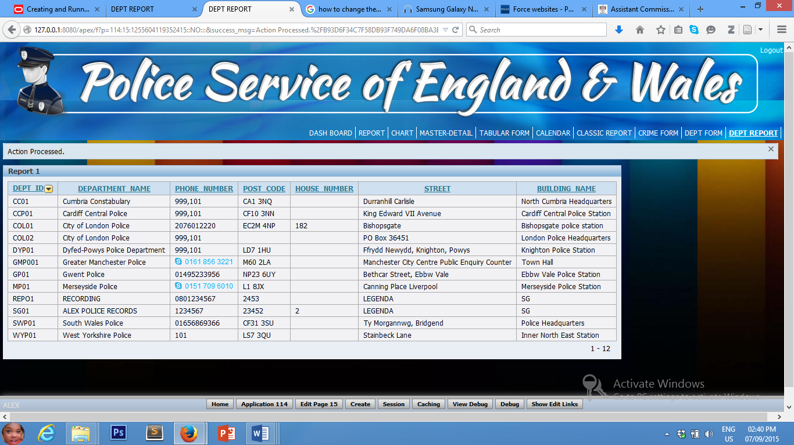REPORT)**

NEW RECORD INSERTED

Screen 2 shows a new record **inserted** into the department table. The record was inserted into department form, which as an action, redirects the page to department report.

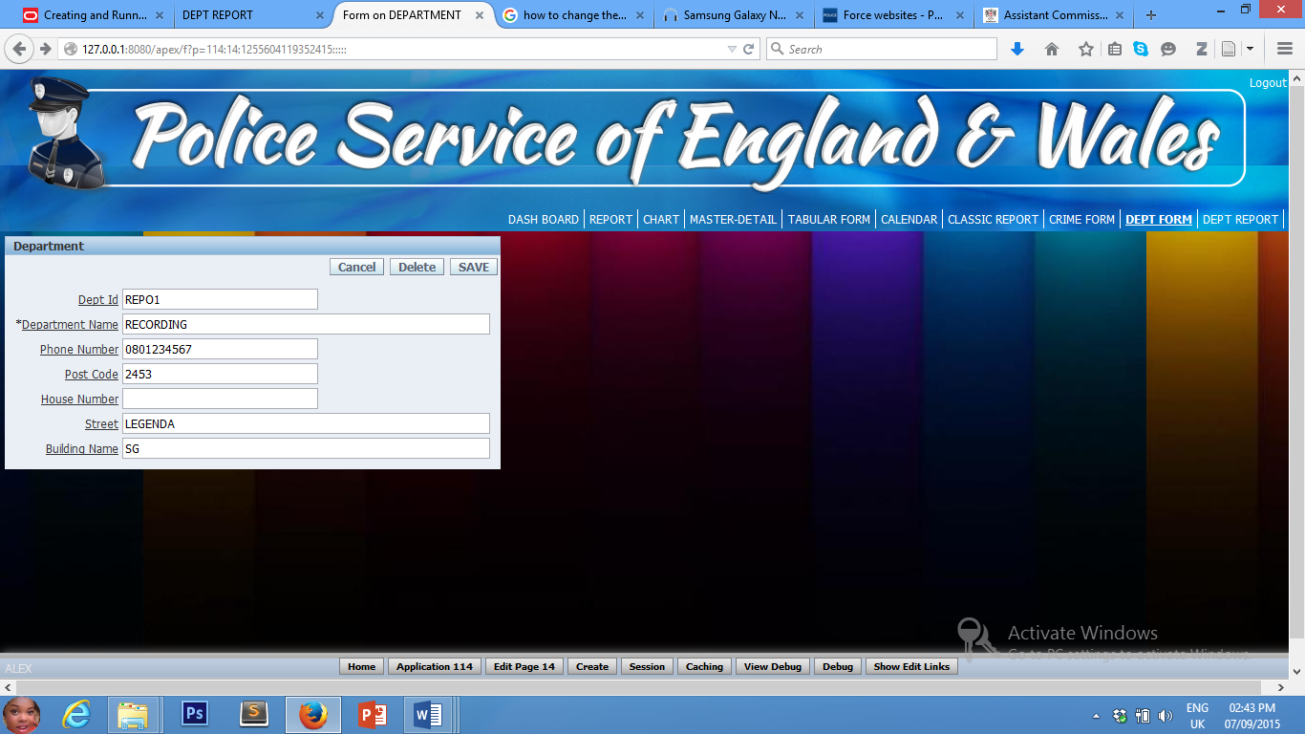**SCREEN 3: UPDATE (DEPARTMENT FORM)**

Screen 3 shows the department form to insert records into the department table.

**SCREEN 4: DELETE (DEPARTMENT)**

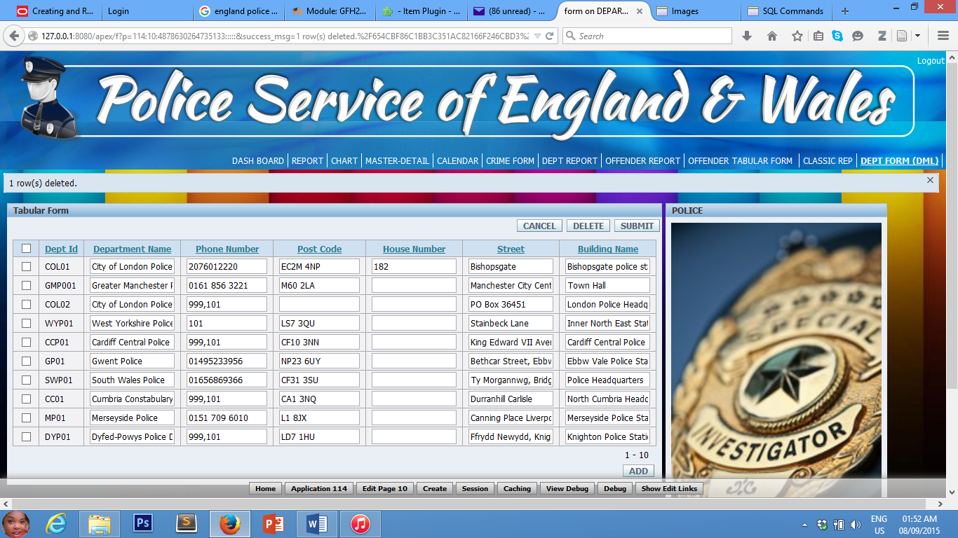

This is a tabular form of crime table where DML activities can be carried out.

**SCREEN 5: MASTER-DETAILS FORM WITH**

**(DML (INSERT/UPDATE) ACTIVITY PERFORMED)**

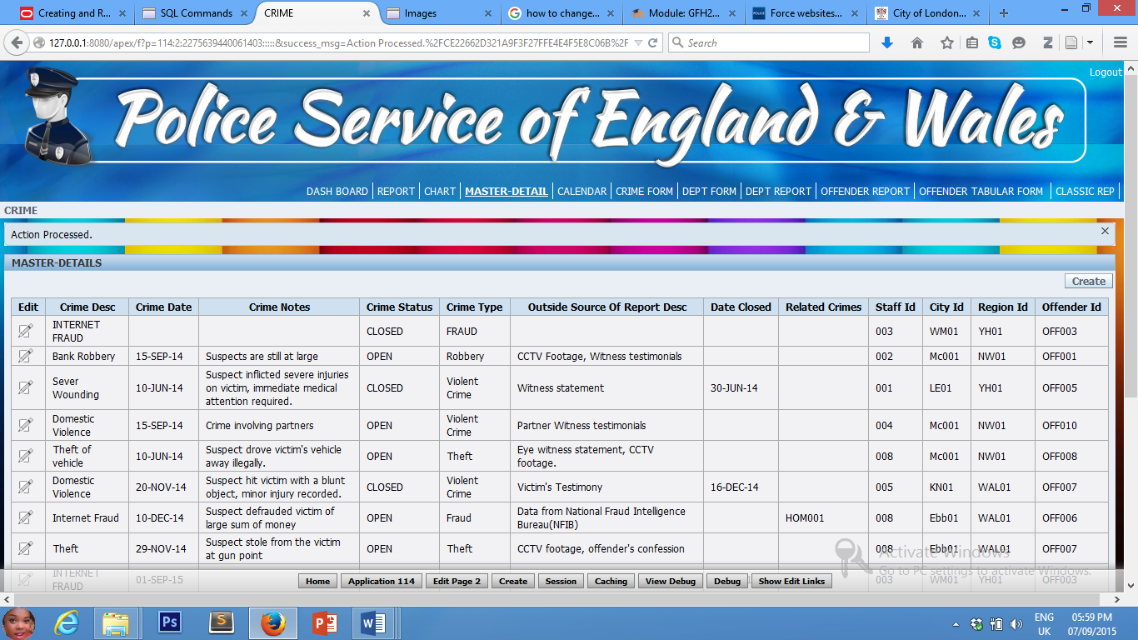

Record inserted

This is a Master-Detail form with a new record inserted.

**TASK 3 IMPLEMENT 3 SUITABLE REPORTS BASED ON SQL QUERIES**

**SCREEN 1: CLASSIC REPORT**

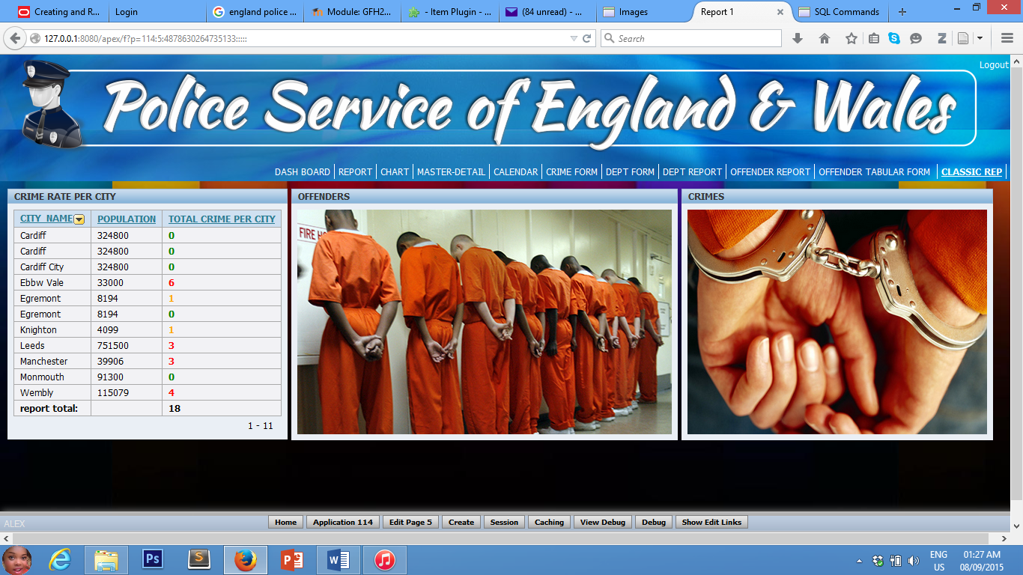

This is a classic report based on one of the views. It shows the total crime per city.

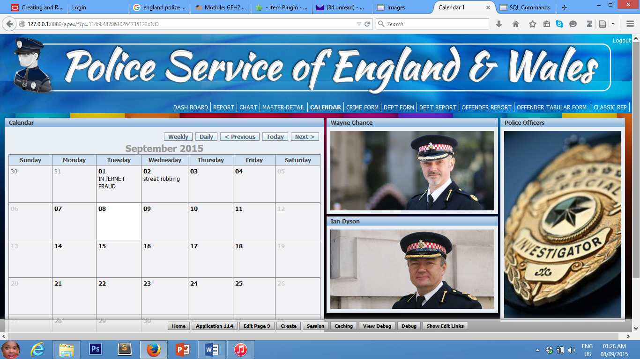**SCREEN 2: CALENDAR**

Screen 2 shows a calendar that displays crims on their respective dates and the types of crimes committed on those dates.

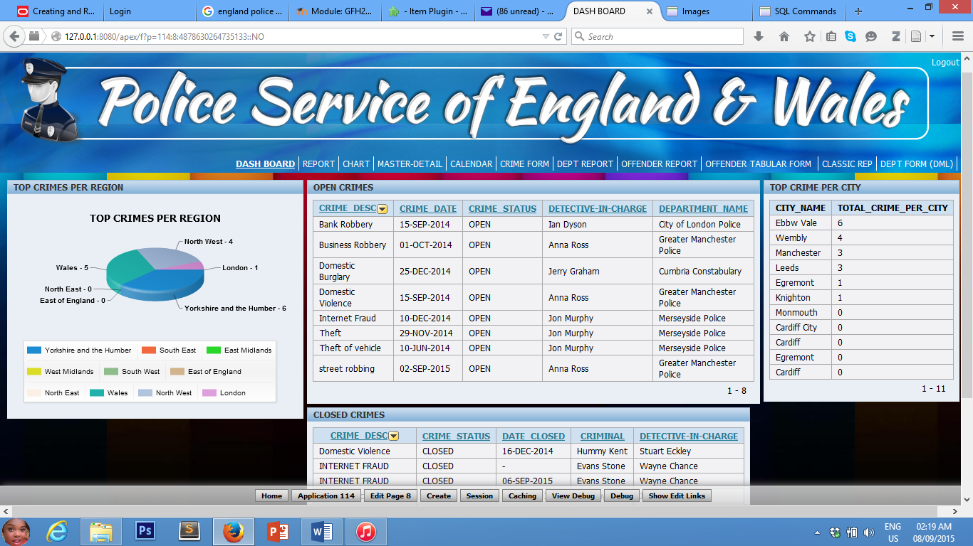**SCREEN 3: DASHBOARB**

This is a dashboard with four (4) regions; all of which were implemented using appropriate SQL queries.

From the top-left, the Chat shows the regions and the total crimes committed within the regions. The Open-Crimes form shows all pending crimes, the detectives-in-charge and the crime dates amongst others.

Top-Crime-per-City form shows the city names and the number of crimes recorded within the cities; while the Closed-Crimes form displays details of all closed crimes.

**N/B:** all the SQL queries used to implement these regions have been included in Views and APEX sections.

**TASK 4: IMPLEMENT 2 TRIGGERS AS PROCEDURAL CONSTRAINTS FOR USE WITHIN THE APEX APPLICATION.**

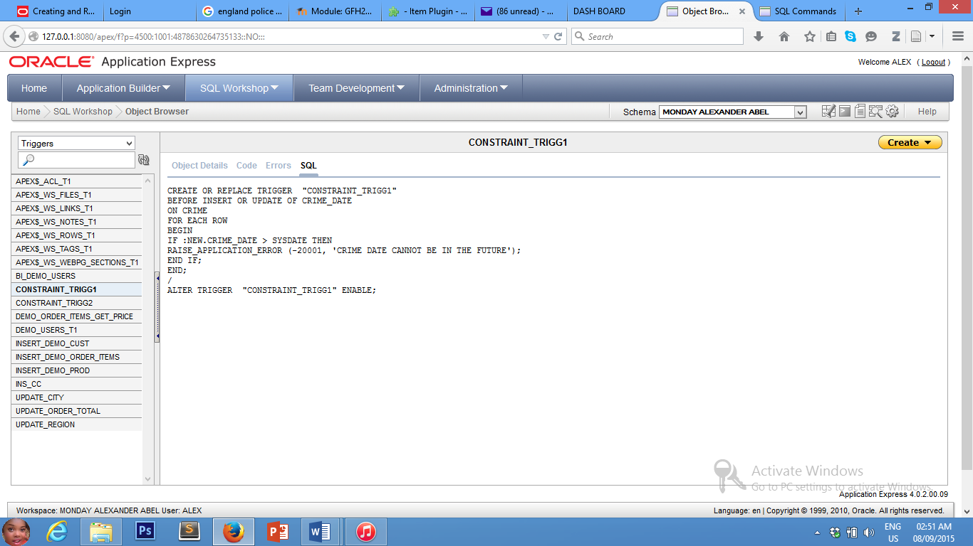**Trigger 1: Constraint_Trigg1**

**TRIGGER1 TEST:**

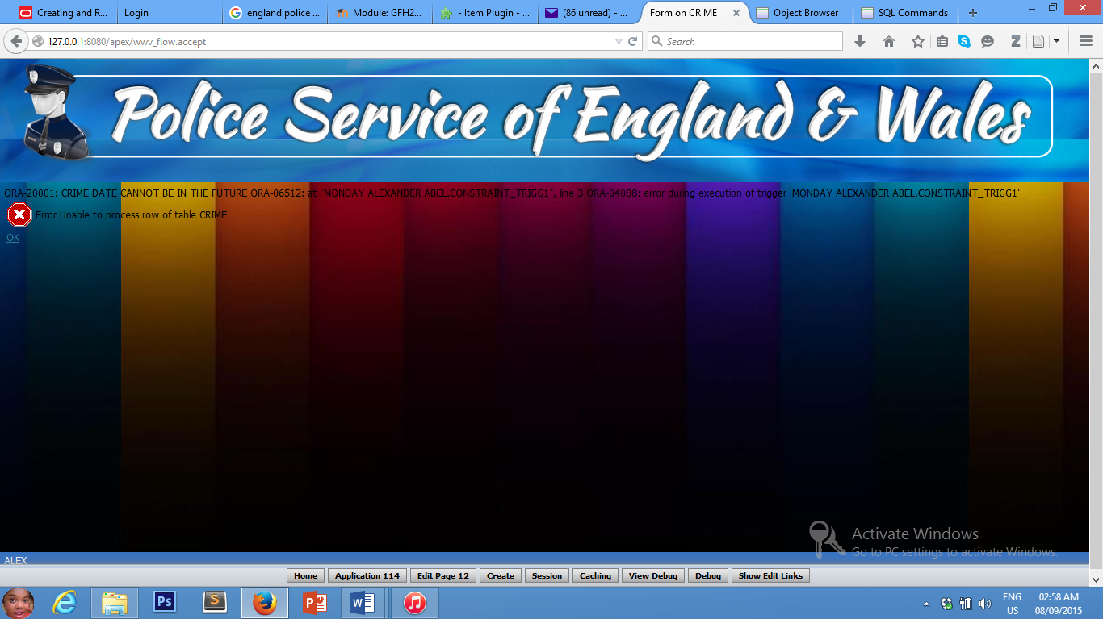

ORA-20001: CRIME DATE CANNOT BE IN THE FUTURE…

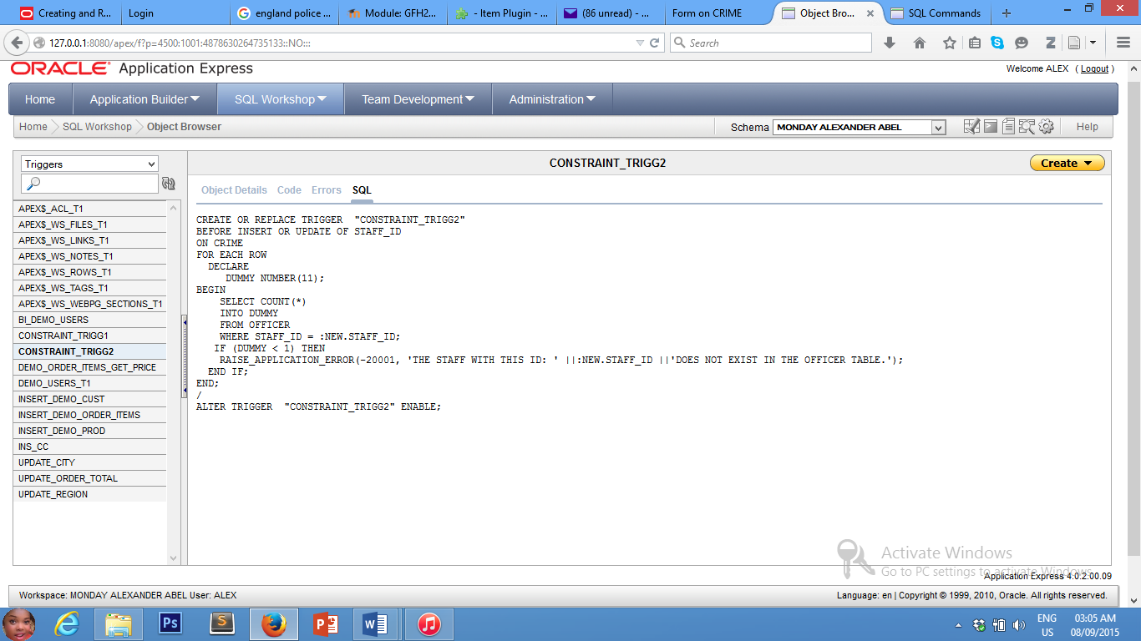**Trigger 1: Constraint_Trigg2**

**TRIGGER2 TEST:**

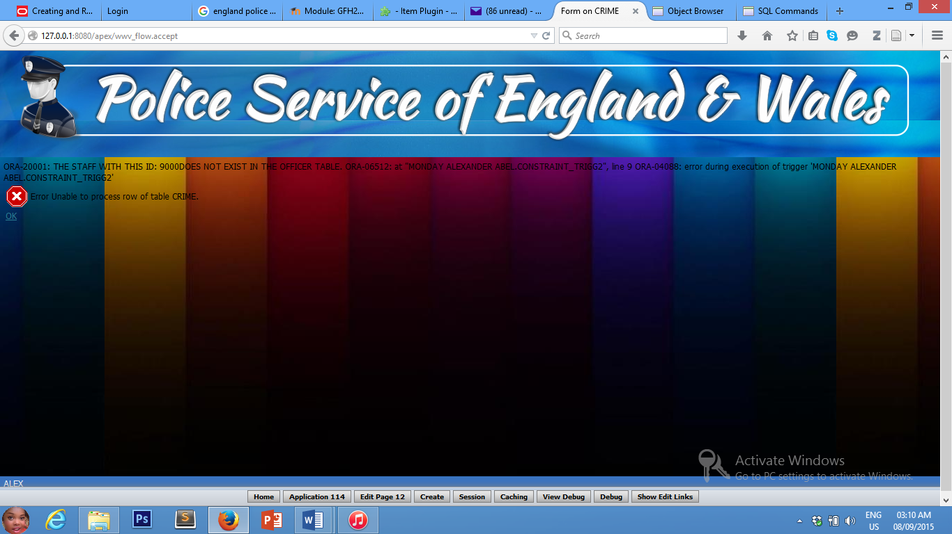

ORA-20001: THE STAFF WITH THIS ID: 9000DOES NOT EXIST IN THE OFFICER TABLE…

**TASK 5: CREATE A USER GUIDE FOR ONE OF YOUR APEX PAGES**

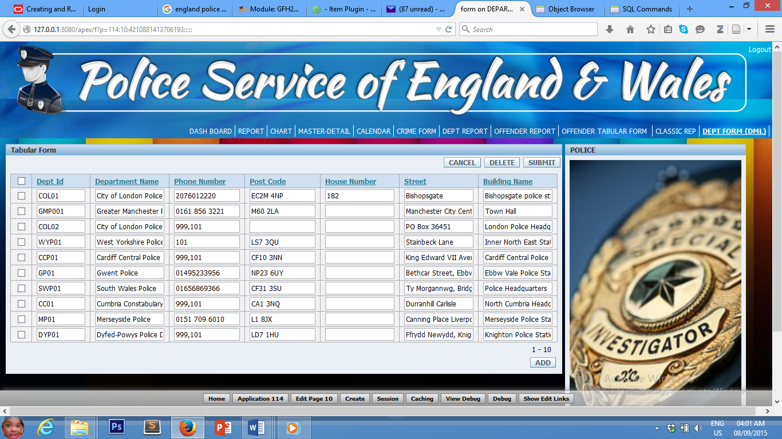

6

7

5

4

3

2

1

8

1. Add
2. Submit
3. Delete
4. Cancel
5. Department details
6. Navigation tabs
7. Multiple selection
8. Goto.

**Department Form**

This application generally allows user manage department details. It allows the user carry out the following DML activities:

1. Delete from department records
2. Update the existing records
3. Add to the existing records and also to
4. View the existing records.

To add new department details

1. Click the add(1) button
2. Enter the details correctly
3. Click the submit(2) button.

To update the existing records

1. On the display form, make your changes
2. Click the submit(2) button.

To delete records

1. Select the desired records to be deleted using the multiple selection option (7).
2. Click the delete(3) button.

* Use the tabs(6) to navigate to any page of your choice.
* Use the goto(8) section to edit the application definition.

CREATE TABLE "DEPARTMENT"

( "DEPT_ID" VARCHAR2(10) NOT NULL ENABLE,

"DEPARTMENT_NAME" VARCHAR2(50) NOT NULL ENABLE,

"PHONE_NUMBER" NUMBER(12,0),

"POST_CODE" NUMBER(9,2),

"HOUSE_NUMBER" NUMBER(3,0),

"STREET" VARCHAR2(50),

"BUILDING_NAME" VARCHAR2(100),

PRIMARY KEY ("DEPT_ID") ENABLE

) ;

CREATE TABLE "REGION"

( "REGION_ID" VARCHAR2(10),

"REGION_NAME" VARCHAR2(50) NOT NULL ENABLE,

"COUNTRY_NAME" VARCHAR2(50) NOT NULL ENABLE,

"TOTAL_NUMBERS_PER_REGION" NUMBER(10,0),

PRIMARY KEY ("REGION_ID") ENABLE

) ;

CREATE TABLE "CITY"

( "CITY_ID" VARCHAR2(10) NOT NULL ENABLE,

"CITY_NAME" VARCHAR2(50) NOT NULL ENABLE,

"LOCATION_NAME" VARCHAR2(50),

"LOCATION_ID" VARCHAR2(10) NOT NULL ENABLE,

"POSTCODE" NUMBER(9,2),

"POPULATION" NUMBER(10,0),

"REGION_ID" VARCHAR2(10),

"HOUSENO" VARCHAR2(10),

"STREET" VARCHAR2(100),

PRIMARY KEY ("CITY_ID") ENABLE

) ;ALTER TABLE "CITY" ADD CONSTRAINT "FK_CY" FOREIGN KEY ("LOCATION_ID")

REFERENCES "CITY" ("CITY_ID") ENABLE;ALTER TABLE "CITY" ADD FOREIGN KEY ("REGION_ID")

REFERENCES "REGION" ("REGION_ID") ENABLE;

**Department Table**

**Region Table**

**City Table**

CREATE TABLE "OFFICER"

( "STAFF_ID" VARCHAR2(10),

"NAME" VARCHAR2(50),

"RANK" VARCHAR2(20),

"DEPARTMENT" VARCHAR2(50),

"PLACE_OF_WORK" VARCHAR2(50),

"HIRE_DATE" DATE,

"INSPECTOR_ID" VARCHAR2(10) NOT NULL ENABLE,

"DEPARTMENT_ID" VARCHAR2(10) NOT NULL ENABLE,

"CITY_ID" VARCHAR2(10) NOT NULL ENABLE,

PRIMARY KEY ("STAFF_ID") ENABLE

) ;ALTER TABLE "OFFICER" ADD FOREIGN KEY ("INSPECTOR_ID")

REFERENCES "OFFICER" ("STAFF_ID") ENABLE;ALTER TABLE "OFFICER" ADD FOREIGN KEY ("DEPARTMENT_ID")

REFERENCES "DEPARTMENT" ("DEPT_ID") ENABLE;ALTER TABLE "OFFICER" ADD FOREIGN KEY ("CITY_ID")

REFERENCES "CITY" ("CITY_ID") ENABLE;

CREATE TABLE "OFFENDER"

( "OFFENDER_ID" VARCHAR2(10),

"NAME" VARCHAR2(50),

"DOB" DATE,

"HOUSE_NUMBER" NUMBER(3,0),

"STREET" VARCHAR2(20),

"TOWN" VARCHAR2(20),

"COUNTRY" VARCHAR2(20),

"POSTCODE" NUMBER(10,0),

"OCCUPATION" VARCHAR2(20),

"NATIONALITY" VARCHAR2(20),

"RACE" VARCHAR2(20),

"RELIGION" VARCHAR2(20),

PRIMARY KEY ("OFFENDER_ID") ENABLE

)

CREATE TABLE "CRIME_COMMITTED"

( "CRIME_NUMBER" VARCHAR2(10),

"OFFENDER_ID" VARCHAR2(10),

CONSTRAINT "PK_CC" PRIMARY KEY ("CRIME_NUMBER", "OFFENDER_ID") ENABLE

) ;ALTER TABLE "CRIME_COMMITTED" ADD FOREIGN KEY ("CRIME_NUMBER")

REFERENCES "CRIME" ("CRIME_NUMBER") ENABLE;ALTER TABLE "CRIME_COMMITTED" ADD FOREIGN KEY ("OFFENDER_ID")

REFERENCES "OFFENDER" ("OFFENDER_ID") ENABLE;

**Officer Table**

**Offender Table**

**Crime Committed Table**

insert into region values('NW01', 'North West', 'Greater Manchester', 0);

insert into region values('LN01', 'London', 'Middlesex', 0);

insert into region values('YH01', 'Yorkshire and the Humber', 'West Yorkshire', 0);

insert into region values('SE01', 'South East', 'Cambridgeshire', 0);

insert into region values('EM01', 'East Midlands', 'Nottingshire', 0);

insert into region values('WM01', 'West Midlands', 'West Midlands', 0);

insert into region values('SW01', 'South West', 'Worcestershire', 0);

insert into region values('EE01', 'East of England', 'Bedfordshire', 0);

insert into region values('NE01', 'North East', 'Northumberland', 0);

insert into region values('WAL01', 'Wales', 'Dyfed-Powys', 0);

insert into department (dept_id, department_name, phone_number, post_code, street, building_name)

values('GMP001', 'Greater Manchester Police', '0161 856 3221', 'M60 2LA', 'Manchester City Centre Public Enquiry Counter', 'Town Hall')

insert into department values('COL01', 'City of London Police', 02076012220, 'EC2M 4NP', 182, 'Bishopsgate', 'Bishopsgate police station')

insert into department (dept_id, department_name, phone_number, street, building_name)

values('COL02', 'City of London Police', '999,101', 'PO Box 36451', 'London Police ​Headquarters')

insert into department (dept_id, department_name, phone_number, post_code, street, building_name)

values('WYP01', 'West Yorkshire Police', '101', 'LS7 3QU', 'Stainbeck Lane', 'Inner North East Station')

insert into department (DEPT_ID, DEPARTMENT_NAME, PHONE_NUMBER, POST_CODE, STREET, BUILDING_NAME)

values('CCP01', 'Cardiff Central Police', '999,101', 'CF10 3NN', 'King Edward VII Avenue', 'Cardiff Central Police Station')

insert into department (DEPT_ID, DEPARTMENT_NAME, PHONE_NUMBER, POST_CODE, STREET, BUILDING_NAME)

values('GP01', 'Gwent Police', '01495233956', 'NP23 6UY', 'Bethcar Street, Ebbw Vale', 'Ebbw Vale Police Station')

insert into department (DEPT_ID, DEPARTMENT_NAME, PHONE_NUMBER, POST_CODE, STREET, BUILDING_NAME)

values('SWP01', 'South Wales Police', '01656869366', 'CF31 3SU', 'Ty Morgannwg, Bridgend', 'Police Headquarters')

insert into department (DEPT_ID, DEPARTMENT_NAME, PHONE_NUMBER, POST_CODE, STREET, BUILDING_NAME)

values('MP01', 'Merseyside Police', '0151 709 6010', 'L1 8JX', 'Canning Place Liverpool', 'Merseyside Police Station')

insert into department (DEPT_ID, DEPARTMENT_NAME, PHONE_NUMBER, POST_CODE, STREET, BUILDING_NAME)

values('CC01', 'Cumbria Constabulary', '999,101', 'CA1 3NQ', 'Durranhill Carlisle', 'North Cumbria Headquarters')

insert into department (DEPT_ID, DEPARTMENT_NAME, PHONE_NUMBER, POST_CODE, STREET, BUILDING_NAME)

values('DYP01', 'Dyfed-Powys Police Department', '999,101', 'LD7 1HU', 'Ffrydd Newydd, Knighton, Powys', 'Knighton Police Station')

**INSERT INTO REGION**

**INSERT INTO DEPARTMENT**

insert into officer values('001', 'Adrian Leppard', 'Commissioner', 'City of London Police', 'Police Headquarters', '08/13/1984', '001', 'COL01', 'LE01')

insert into officer values('002', 'Ian Dyson', 'Assist. Commissioner', 'City of London', 'Police Headquarters', '07/01/1983', '001', 'COL01', 'Mc001')

insert into officer values('003', 'Wayne Chance', 'Commander of Op.', 'City of London', 'Police Headquarters', '08/13/1986', '002', 'COL01', 'WM01')

insert into officer values('004', 'Anna Ross', 'Sergeant', 'Manchester City Police Department', 'Greater Manchester Police', '03/11/2010', '003', 'GMP001', 'Mc001')

insert into officer values('005', 'Stuart Eckley', 'Inspector', 'Dyfed-Powys Police Department', 'Llandrindod Wells', '12/01/1989', '005', 'DYP01', 'KN01')

insert into officer values('006', 'Jerry Graham', 'Chief Constable', 'Cumbria Constabulary', 'Whitehaven, Cumbria', '01/01/1985', '001', 'CC01', 'EG02')

insert into officer values('007', 'Kevin Warren', 'Inspector', 'Gwent Police', 'Alway, Lliswerry and Ringland', '01/01/1989', '007', 'GMP001', 'Ebb01')

insert into officer values('008', 'Jon Murphy', 'Chief Constable', 'Merseyside Police force', 'Everton, Anfield', '03/30/1975', '008', 'MP01', 'LE01')

insert into officer values('009', 'Matt Scrase ', 'Inspector', 'Dyfed-Powys Police Department', 'Brecon Town', '01/01/1994', '009', 'DYP01', 'KN01')

insert into officer values('010', 'Huw Jones', 'Inspector', 'Gwent Police Department', 'Wyesham, Monmouth', '01/01/1999', '007', 'GMP001', 'Ebb01')

desc city

SELECT * FROM CITY

DELETE FROM CITY where city_id='MN01'

alter table city drop column location_ID cascade constraint

alter table city modify postcode varchar2(10)

insert into city (city_id, city_name, location_name, postcode, population, region_id, street)

values('Mc001', 'Manchester', 'Old Trafford', 'M16 0RA', 39906, 'NW01', 'Sir Matt Busby Way')

insert into city (city_id, city_name, location_name, postcode, population, region_id, street)

values('LE01', 'Leeds', 'Leeds Metropolitan University', 'LS6 3QS', '751500', 'YH01', 'The Grange, Headingley Campus')

insert into city (city_id, city_name, location_name, postcode, population, region_id, street)

values('CAR001', 'Cardiff', 'Cardiff Metropolitan University', 'CF5 2SG', '324800', 'Wal02', 'Western Avenue')

insert into city (city_id, city_name, location_name, postcode, population, region_id, street)

values('CAR002', 'Cardiff', 'Cardiff University', 'CF10 3AT', '324800', 'Wal02', 'Main Building, Park Place')

insert into city (city_id, city_name, location_name, postcode, population, region_id, street)

values('WM01', 'Wembly', 'Wembley Football Stadium', 'HA9 0WS', '115079', 'LN01', 'On or near High Road')

insert into city values('EG01', 'Egremont', 'Lowes Court Gallery', 'CA22 2DW', '8194', 'NW01', 12, 'Main Street')

insert into city (city_id, city_name, location_name, postcode, population, region_id, street)

values('CC01', 'Cardiff City', 'Ninian Park', 'CF11 8AZ', '324800', 'Wal02', 'Leckwith Rd')

insert into city (city_id, city_name, location_name, postcode, population, region_id, street)

values('Ebb01', 'Ebbw Vale', 'Victoria Business Park', 'NP23 8AN', '33000', 'Wal01', 'Waunllwyd')

insert into city (city_id, city_name, location_name, population, region_id, houseno, street)

values('MM01', 'Monmouth', 'Cedar Avenue', '91300', 'Wal03', '400', 'West Long Branch')

insert into city values('EG02', 'Egremont', 'Florence Mine', 'CA22 2DB', 8194, 'NW01', 70, 'Main Street')

insert into city (city_id, city_name, location_name, population, region_id, street)

values('KN01', 'Knighton', 'Milebrook House Hotel', '4099', 'WAL01', 'Knighton, Powys')

**INSERT INTO OFFICER**

**INSERT INTO CITY**

//CRIME TABLE

alter table crime modify crime_date date

select sysdate from dual

DESC CRIME

SELECT * FROM CRIME

alter table crime modify crime_desc varchar2(200)

alter table crime add constraint fk_rc foreign key (related_crimes) referencing crime(crime_number)

insert into crime (crime_number, crime_desc, crime_date, crime_notes, crime_status, crime_type, outside_source_of_report_desc, date_closed, staff_id, location_id)

values('HOM001', 'Murder', '08/15/2014', 'Suspect murdered victim using blunt object', 'CLOSED', 'Homicide', 'CCTV Footage, murder weapon', '05/30/2014','003', 'WM01');

insert into crime (crime_number, crime_desc, crime_date, crime_notes, crime_status, crime_type, outside_source_of_report_desc, staff_id, location_id)

values('ROB01', 'Bank Robbery', '09/15/2014', 'Suspects are still at large', 'OPEN', 'Robbery', 'CCTV Footage, Witness testimonials', '002', 'Mc001');

insert into crime (crime_number, crime_desc, crime_date, crime_notes, crime_status, crime_type, outside_source_of_report_desc, date_closed, staff_id, location_id)

values('VC001', 'Sever Wounding', '06/10/2014', 'Suspect inflicted severe injuries on victim, immediate medical attention required.', 'CLOSED', 'Violent Crime', 'Witness statement', '06/30/2014','001', 'LE01');

insert into crime (crime_number, crime_desc, crime_date, crime_notes, crime_status, crime_type, outside_source_of_report_desc, staff_id, location_id)

values('VC002', 'Domestic Violence', '09/15/2014', 'Crime involving partners', 'OPEN', 'Violent Crime', 'Partner Witness testimonials', '004', 'Mc001');

insert into crime (crime_number, crime_desc, crime_date, crime_notes, crime_status, crime_type, outside_source_of_report_desc, staff_id, location_id)

values('ROB02', 'Business Robbery', '10/01/2014', 'Suspect robbed a shop with the aid of an accomplice', 'OPEN', 'Robbery', 'CCTV Footage', '004', 'LE01');

insert into crime (crime_number, crime_desc, crime_date, crime_notes, crime_status, crime_type, outside_source_of_report_desc, staff_id, location_id)

values('VC003', 'Domestic Violence', '11/20/2014', 'Suspect hit victim with a blunt object, minor injury recorded.', 'CLOSED', 'Violent Crime', 'Victim''s Testimony', '005', 'KN01');

insert into crime (crime_number, crime_desc, crime_date, crime_notes, crime_status, crime_type, outside_source_of_report_desc, related_crimes, staff_id, location_id)

values('BURG01', 'Domestic Burglary', '12/25/2014', 'Suspect broke into victim''s apartment, several items were reportedly missing.', 'OPEN', 'Theft', 'CCTV footage, fingerprints.', 'VC003', '006', 'EG02');

insert into crime (crime_number, crime_desc, crime_date, crime_notes, crime_status, crime_type, outside_source_of_report_desc, related_crimes, staff_id, location_id)

values('PPT01', 'Personal property theft', '04/22/2014', 'Suspect stole item of value from victim.', 'CLOSED', 'Theft', 'Eye witness statement.', 'VC001', '001', 'LE01');

insert into crime (crime_number, crime_desc, crime_date, crime_notes, crime_status, crime_type, outside_source_of_report_desc, staff_id, location_id)

values('TV01', 'Theft of vehicle', '06/10/2014', 'Suspect drove victim''s vehicle away illegally.', 'OPEN', 'Theft', 'Eye witness statement, CCTV footage.', '008', 'Mc001');

insert into crime (crime_number, crime_desc, crime_date, crime_notes, crime_status, crime_type, outside_source_of_report_desc, related_crimes, staff_id, location_id)

values('IF01', 'Internet Fraud', '12/10/2014', 'Suspect defrauded victim of large sum of money', 'OPEN', 'Fraud', 'Data from National Fraud Intelligence Bureau(NFIB)', 'HOM001', '008', 'Ebb01');

**INSERT INTO CRIME**

//OFFENDER TABLE

select * from offender

desc offender

alter table offender modify postcode varchar2(10)

//INSERTED

insert into offender values('OFF001', 'John Doe', '01/23/1975', 224, 'Hawthorne road', 'Bootle', 'Merseyside', 'L20', 'Student', 'Malaysia', 'White', 'Islam')

insert into offender values('OFF002', 'James Cornor', '12/13/1986', 12, 'Parsoloes Patrk road', 'Barking', 'Greater London', 'IG11', 'Technician', 'Indian', 'Asian', 'Hindu')

insert into offender values('OFF003', 'Evans Stone', '10/19/1979', 151, 'Ferry Rd', 'Isle Of Dogs', 'East London', 'E14 3BT', 'Electrician', 'England', 'White', 'Christian')

insert into offender values('OFF004', 'Ian Pupa', '02/09/1990', 98, 'High School Rd.', 'Earl Shilton', 'Leicestershire', 'LE9', 'Musician', 'Pakistan', 'Asian', 'Islam')

insert into offender values('OFF005', 'Van Stein', '10/27/1988', 70, 'Longelandes way', 'Banbury', 'Oxfordshire', 'OX16', 'Technician', 'Indian', 'Asian', 'Hindu')

insert into offender values('OFF006', 'Joe Forg', '09/15/1987', 14, 'Wilson Rd', 'Ely', 'Cardiff', 'CF5', 'Footballer', 'Scotland', 'White', 'Others')

insert into offender values('OFF007', 'Hummy Kent', '12/20/1981', 17, 'Abergavenny', 'Ebbw Vale', 'Gwent', 'IG11', 'Trader', 'Scotland', 'White', 'Islam')

insert into offender values('OFF008', 'Jeremy Flint', '12/25/1984', 11, 'Old Street', 'Hoxton', 'Central London', 'N1', 'Entertainer', 'Nigerian', 'Black', 'Islam')

insert into offender values('OFF009', 'David Jones', '06/23/1988', 03, 'Stadium Road', 'Wembley', 'Middlesex', 'HA0', 'Footballer', 'Nigerian', 'Black', 'Christian')

insert into offender values('OFF010', 'Jack Jones', '08/23/1991', 15, 'Main Street', 'Manchester', 'Greater Manchester', 'M60', 'Footballer', 'Mozambique', 'Black', 'Islam')

//CRIMES COMMITTED

DESC CRIME_COMMITTED

INSERT INTO CRIME_COMMITTED VALUES ('ROB01', 'OFF001')

INSERT INTO CRIME_COMMITTED VALUES ('VC001', 'OFF005')

INSERT INTO CRIME_COMMITTED VALUES ('TV01', 'OFF008')

INSERT INTO CRIME_COMMITTED VALUES ('VC002', 'OFF010')

INSERT INTO CRIME_COMMITTED VALUES ('VC003', 'OFF007')

INSERT INTO CRIME_COMMITTED VALUES ('IF01', 'OFF006')

INSERT INTO CRIME_COMMITTED VALUES ('HOM001', 'OFF003')

INSERT INTO CRIME_COMMITTED VALUES ('ROB02', 'OFF002')

INSERT INTO CRIME_COMMITTED VALUES ('BURG01', 'OFF004')

INSERT INTO CRIME_COMMITTED VALUES ('PPT01', 'OFF009')

SELECT * FROM REGION

SELECT * FROM OFFENDER

SELECT * FROM CRIME

SELECT * FROM CITY

SELECT * FROM CRIME WHERE LOCATION_ID = 'Ebb01'

UPDATE REGION SET TOTAL_NUMBER_PER_REGION = 4 WHERE REGION_ID = 'NW01'

UPDATE REGION SET TOTAL_NUMBER_PER_REGION = 3 WHERE REGION_ID = 'YH01'

UPDATE REGION SET TOTAL_NUMBER_PER_REGION = 2 WHERE REGION_ID = 'Wal01'

UPDATE REGION SET TOTAL_NUMBER_PER_REGION = 1 WHERE REGION_ID = 'LN01'

**INSERT INTO OFFENDER**

**INSERT INTO CRIME_COMMITTED**

**SOME DML**

//--- TRIGGERS ---\\

//MAKE A TRIGGER THAT WILL AUTOMATICALLY UPDATE THE REGION TABLE IF NEW CRIMES ARE RECORDED IN A PARTICULAR REGION.

//SINCE THERE IS NO DIRECT RELATIONSHIP BETWEEN CRIME AND REGION TABLES, THE LOCATION_ID ON THE CRIME TABLE SHOULD BE SPLIT INTO TWO (REGION_ID & CITY_ID).

//ALSO, THERE IS NEED TO CHECK THE NUMBER OF CRIMES REPORTED IN A PARTICULAR CITY. SO, A NEW ROW WILL BE ADDED TO THE CITY TABLE AND A TRIGGER WILL BE CREATED TO CALCULATE THIS ROW.

//FIRST ALTER CRIME AND CHANGE LOCATION_ID TO CITY_ID

ALTER TABLE CRIME RENAME COLUMN LOCATION_ID TO CITY_ID

//CHECK

SELECT * FROM CRIME

//SECONDLY ADD A NEW COLUMN NAMED REGION_ID AND REFERENCE IT TO REGION_ID IN THE REGION TABLE

ALTER TABLE CRIME ADD REGION_ID VARCHAR2(10) REFERENCES REGION(REGION_ID)

//CHECK

SELECT * FROM CRIME

//NOW INSERT VALUES INTO THE NEWLY CREATED COLUMN IN CRIME TABLE

UPDATE CRIME SET REGION_ID = 'NW01' WHERE CITY_ID = 'Mc001'

UPDATE CRIME SET REGION_ID = 'YH01' WHERE CITY_ID = 'LE01'

UPDATE CRIME SET REGION_ID = 'WAL01' WHERE CITY_ID = 'KN01'

UPDATE CRIME SET REGION_ID = 'WAL01' WHERE CITY_ID = 'Ebb01'

UPDATE CRIME SET REGION_ID = 'LN01' WHERE CITY_ID = 'WM01'

UPDATE CRIME SET REGION_ID = 'NW01' WHERE CITY_ID = 'EG02'

//CHECK

SELECT * FROM CRIME

//NEXT ADD A NEW COLUMN IN CITY TABLE THAT STORES THE TOTAL CRIME IN EACH CITY.

ALTER TABLE CITY ADD TOTAL_CRIME_PER_CITY NUMBER(11)

//CHECK

SELECT * FROM CITY

//INSERT AN INITIAL VALUE OF ZERO TO THE NEWLY CREATED ROW IN CITY TABLE

UPDATE CITY SET TOTAL_CRIME_PER_CITY =0

//CHECK

SELECT * FROM CITY

//MANUALLY COUNT (OR USE SQL TO COUNT) THE NUMBER OF RECORDED CRIMES IN EACH CITY AND INSERT THE CORRESPONDING VALUE.

SELECT * FROM CRIME

UPDATE CITY SET TOTAL_CRIME_PER_CITY = 3 WHERE CITY_ID = 'Mc001'

UPDATE CITY SET TOTAL_CRIME_PER_CITY = 3 WHERE CITY_ID = 'LE01'

UPDATE CITY SET TOTAL_CRIME_PER_CITY = 1 WHERE CITY_ID = 'KN01'

**TRIGGERS**

UPDATE CITY SET TOTAL_CRIME_PER_CITY = 1 WHERE CITY_ID = 'Ebb01'

UPDATE CITY SET TOTAL_CRIME_PER_CITY = 1 WHERE CITY_ID = 'WM01'

UPDATE CITY SET TOTAL_CRIME_PER_CITY = 1 WHERE CITY_ID = 'EG02'

//CHECK

SELECT * FROM CITY

SELECT * FROM REGION

//NOW CREATE A TRIGGER THAT WILL UPDATE THE TOTAL_CRIME_PER_CITY COLUMN IN THE CITY TABLE WHENEVER A NEW CRIME IS RECORDED.

CREATE OR REPLACE TRIGGER UPDATE_CITY

AFTER INSERT OR UPDATE OF CITY_ID

ON CRIME

FOR EACH ROW

BEGIN

UPDATE CITY SET TOTAL_CRIME_PER_CITY = TOTAL_CRIME_PER_CITY + 1

WHERE CITY_ID = :NEW.CITY_ID;

END;

//CHECK

DESC REGION

DESC OFFICER

DESC CRIME

//AND FINALLY CREATE A TRIGGER THAT WILL UPDATE THE TOTAL_NUMBER_PER_REGION ON THE REGION TABLE

CREATE OR REPLACE TRIGGER UPDATE_REGION

AFTER INSERT OR UPDATE OF REGION_ID

ON CRIME

FOR EACH ROW

BEGIN

UPDATE REGION SET TOTAL_NUMBER_PER_REGION = TOTAL_NUMBER_PER_REGION +1

WHERE REGION_ID =:NEW.REGION_ID;

END;

**TRIGGERS (CONTINUED)**

**DATABASE SYSTEM REQUIREMENTS (CASE SCENARIO)**

//DATABASE SYSTEM REQUIREMENTS\\

1.) Ability to record and retrieve crime, date and crime code

select crime_number as "Crime Code", crime_desc, crime_date from crime

2.) Ability to identify the police officer who recorded notes about the crime and also details of the person who reported the crime

select o.name as "Officer Name", c.crime_desc, c.crime_notes from officer o, crime c where c.staff_id = o.staff_id

3.) Ability to retrieve crime data for each county and city

SELECT COUNTY_NAME, TOTAL_NUMBER_PER_REGION FROM REGION WHERE TOTAL_NUMBER_PER_REGION >0

OR

SELECT C.CRIME_DESC, R.COUNTY_NAME, R.TOTAL_NUMBER_PER_REGION FROM CRIME C, REGION R

WHERE TOTAL_NUMBER_PER_REGION>0 AND

C.REGION_ID = R.REGION_ID

4.) Police would like to retrieve data on closed and open crimes

select crime_number, crime_desc, crime_status, crime_date, date_closed from crime

5.) Ability to record data about the offender and the objects used to commit the crime

SELECT O.NAME AS "OFFENDER NAME", C.CRIME_NOTES, C.CRIME_DESC FROM OFFENDER O, CRIME C

6.) Ability to identify if a crime is associated with one or many events

SELECT CRIME_NUMBER, CRIME_DESC, RELATED_CRIMES FROM CRIME

WHERE RELATED_CRIMES !='NULL'

7.)//NO WITNESS AND VICTIM TABLES\\

8.) Ability to record and retrieve details about the offender's history if he has committed more than one crime

//BEFORE THIS CAN BE DONE SUCCESSFULLY, CERTAIN ALTERATIONS HAS TO BE CARRIED OUT ON THE TABLES.

//THERE SHOULD BE A MEANS TO IDENTIFY WHICH OFFENDER COMMITTED A PARTICULAR CRIME. FOR THIS REASON, THE CRIME TABLE SHOULD BE ALTERED TO INCLUDE OFFENDER ID

alter table crime add offender_id varchar2(10)

alter table crime add constraint fk_oid foreign key (offender_id) references offender (offender_id)

//NOW A NEW TRIGGER SHOULD BE CREATED TO AUTOMATICALLY UPDATE THE CRIME_COMMITTED TABLE WHENEVER A NEW CRIME IS RECORDED

//FIRST UPDATE THE CRIME TABLE WITH THE OFFENDERS

UPDATE CRIME SET OFFENDER_ID = 'OFF004' WHERE CRIME_NUMBER = 'BURG01'

UPDATE CRIME SET OFFENDER_ID = 'OFF002' WHERE CRIME_NUMBER = 'ROB02'

UPDATE CRIME SET OFFENDER_ID = 'OFF003' WHERE CRIME_NUMBER = 'HOM001'

UPDATE CRIME SET OFFENDER_ID = 'OFF005' WHERE CRIME_NUMBER = 'VC001'

UPDATE CRIME SET OFFENDER_ID = 'OFF006' WHERE CRIME_NUMBER = 'IF01'

UPDATE CRIME SET OFFENDER_ID = 'OFF007' WHERE CRIME_NUMBER = 'VC003'

UPDATE CRIME SET OFFENDER_ID = 'OFF008' WHERE CRIME_NUMBER = 'TV01'

UPDATE CRIME SET OFFENDER_ID = 'OFF009' WHERE CRIME_NUMBER = 'PPT01'

UPDATE CRIME SET OFFENDER_ID = 'OFF010' WHERE CRIME_NUMBER = 'VC002'

UPDATE CRIME SET OFFENDER_ID = 'OFF001' WHERE CRIME_NUMBER = 'ROB01'

//CHECK

SELECT * FROM CRIME

//FINALLY, THE TRIGGER

create or replace trigger ins_cc

after insert or update of crime_number

on crime

for each row

begin

insert into crime_committed (crime_number)

values(:New.crime_number);

end;

create or replace trigger ins_cc_offend

after insert or update of offender_id

on crime

for each row

begin

insert into crime_committed (offender_id)

values(:New.offender_id);

//FINALLY

select o.*, c.related_crimes from offender o, crime c

where related_crimes !='NULL'

and c.offender_id = o.offender_id

9.) If the crime is solved the police is able to retrieve information about the date it was solved, the detective who solved it and the who was the criminal.

If it's still pending, who is the detective who investigates it and the department they are working in.

//FOR SOLVED CRIME

SELECT C.CRIME_DESC, C.CRIME_DATE, C.CRIME_STATUS, C.DATE_CLOSED, F.NAME AS "CRIMINAL", O.NAME AS "DETECTIVE-IN-CHARGE" FROM CRIME C, OFFENDER F, OFFICER O

WHERE CRIME_STATUS = 'CLOSED'

AND O.STAFF_ID = C.STAFF_ID

AND C.OFFENDER_ID = F.OFFENDER_ID

9.) \\FOR PENDING CRIMES

SELECT C.CRIME_DESC, C.CRIME_DATE, C.CRIME_STATUS, O.NAME AS "DETECTIVE-IN-CHARGE", D.DEPARTMENT_NAME FROM CRIME C, OFFICER O, DEPARTMENT D

WHERE CRIME_STATUS = 'OPEN'

AND C.STAFF_ID = O.STAFF_ID

AND O.DEPARTMENT_ID = D.DEPT_ID

//

10. and 11. are recursive relationships. Need to figure out how to handle that

\\

10.) Every police officer that recorded notes for a crime has to report to an inspector.

SELECT NAME, RANK, DEPARTMENT FROM OFFICER WHERE INSPECTOR_ID LIKE '%0%'

11.) Every crime has at least one suspect and the police can see if any suspect is previously convicted or accused of another crime

12.) Show details of offenses that have the same officer who supervised an offense happened the 19th of December, 2014.

SELECT * FROM CRIME WHERE CRIME_DATE = '09/15/2014'

13.) list which crimes are related to which, and make it clear by displaying the name, date and number of each crime

14.) We need to know the crime details, along with the details of the officer who reported it

SELECT C.CRIME_NUMBER, C.CRIME_DESC, C.CRIME_DATE, C.CRIME_STATUS, O.NAME FROM CRIME C, OFFICER O

WHERE C.STAFF_ID = O.STAFF_ID

15.) Which department has the highest number of open crimes

SELECT DEPARTMENT_NAME FROM DEPARTMENT WHERE DEPT_ID IN (SELECT DEPT_ID FROM OFFICER WHERE STAFF_ID IN (SELECT STAFF_ID FROM CRIME WHERE CRIME_STATUS = 'OPEN'))

SELECT * FROM CRIME

SELECT * FROM DEPARTMENT

SELECT * FROM OFFICER

//

DEADLOCK!!!

\\

SELECT DEPARTMENT_NAME FROM CRIME WHERE CRIME_STATUS = 'OPEN' AND DEPT_ID IN (SELECT DEPT_ID FROM DEPARTMENT WHERE )

//

DEADLOCK!!!

\\

16.) LIST OF ALL CLOSED CRIMES WHERE THE SUSPECT IS A SUSPECT MORE THAN THREE TIMES

SELECT CRIME_DESC FROM CRIME WHERE CRIME_STATUS = 'CLOSED' AND COUNT()>3

**DATABASE SYSTEM REQUIREMENTS (CASE SCENARIO CONTINUED)**

//CHECK

SELECT * FROM CRIME

//FINALLY, THE TRIGGER

create or replace trigger ins_cc

after insert or update of crime_number

on crime

for each row

begin

insert into crime_committed (crime_number)

values(:New.crime_number);

end;

create or replace trigger ins_cc_offend

after insert or update of offender_id

on crime

for each row

begin

insert into crime_committed (offender_id)

values(:New.offender_id);

//FINALLY

select o.*, c.related_crimes from offender o, crime c

where related_crimes !='NULL'

and c.offender_id = o.offender_id

9.) If the crime is solved the police is able to retrieve information about the date it was solved, the detective who solved it and the who was the criminal.

If it's still pending, who is the detective who investigates it and the department they are working in.

//FOR SOLVED CRIME

SELECT C.CRIME_DESC, C.CRIME_DATE, C.CRIME_STATUS, C.DATE_CLOSED, F.NAME AS "CRIMINAL", O.NAME AS "DETECTIVE-IN-CHARGE" FROM CRIME C, OFFENDER F, OFFICER O

WHERE CRIME_STATUS = 'CLOSED'

AND O.STAFF_ID = C.STAFF_ID

AND C.OFFENDER_ID = F.OFFENDER_ID

9.) \\FOR PENDING CRIMES

SELECT C.CRIME_DESC, C.CRIME_DATE, C.CRIME_STATUS, O.NAME AS "DETECTIVE-IN-CHARGE", D.DEPARTMENT_NAME FROM CRIME C, OFFICER O, DEPARTMENT D

WHERE CRIME_STATUS = 'OPEN'

AND C.STAFF_ID = O.STAFF_ID

AND O.DEPARTMENT_ID = D.DEPT_ID

//

10. and 11. are recursive relationships. Need to figure out how to handle that

\\

10.) Every police officer that recorded notes for a crime has to report to an inspector.

SELECT NAME, RANK, DEPARTMENT FROM OFFICER WHERE INSPECTOR_ID LIKE '%0%'

11.) Every crime has at least one suspect and the police can see if any suspect is previously convicted or accused of another crime

12.) Show details of offenses that have the same officer who supervised an offense happened the 19th of December, 2014.

SELECT * FROM CRIME WHERE CRIME_DATE = '09/15/2014'

13.) list which crimes are related to which, and make it clear by displaying the name, date and number of each crime

14.) We need to know the crime details, along with the details of the officer who reported it

SELECT C.CRIME_NUMBER, C.CRIME_DESC, C.CRIME_DATE, C.CRIME_STATUS, O.NAME FROM CRIME C, OFFICER O

WHERE C.STAFF_ID = O.STAFF_ID

15.) Which department has the highest number of open crimes

SELECT DEPARTMENT_NAME FROM DEPARTMENT WHERE DEPT_ID IN (SELECT DEPT_ID FROM OFFICER WHERE STAFF_ID IN (SELECT STAFF_ID FROM CRIME WHERE CRIME_STATUS = 'OPEN'))

SELECT * FROM CRIME

SELECT * FROM DEPARTMENT

SELECT * FROM OFFICER

//

DEADLOCK!!!

\\

SELECT DEPARTMENT_NAME FROM CRIME WHERE CRIME_STATUS = 'OPEN' AND DEPT_ID IN (SELECT DEPT_ID FROM DEPARTMENT WHERE )

//

DEADLOCK!!!

\\

16.) LIST OF ALL CLOSED CRIMES WHERE THE SUSPECT IS A SUSPECT MORE THAN THREE TIMES

SELECT CRIME_DESC FROM CRIME WHERE CRIME_STATUS = 'CLOSED' AND COUNT()>3

**DATABASE SYSTEM REQUIREMENTS (CASE SCENARIO CONTINUED)**

// VIEWS \\

//VIEW 1\\

create view view_offender

as

select o.name as "Officer Name", c.crime_desc, c.crime_notes

from officer o, crime

c where c.staff_id = o.staff_id

order by o.name

select * from view_offender

//VIEW 2\\

DROP VIEW city_view

select * from city_view

create view city_view

as

SELECT C.CRIME_DESC, R.COUNTY_NAME, R.TOTAL_NUMBER_PER_REGION

FROM CRIME C, REGION R

WHERE TOTAL_NUMBER_PER_REGION>0 AND

C.REGION_ID = R.REGION_ID

ORDER BY TOTAL_NUMBER_PER_REGION DESC

//VIEW 4\\

create view solved_crime_view

as

SELECT C.CRIME_DESC, C.CRIME_DATE, C.CRIME_STATUS, C.DATE_CLOSED, F.NAME AS "CRIMINAL", O.NAME AS "DETECTIVE-IN-CHARGE"

FROM CRIME C, OFFENDER F, OFFICER O

WHERE CRIME_STATUS = 'CLOSED'

AND O.STAFF_ID = C.STAFF_ID

AND C.OFFENDER_ID = F.OFFENDER_ID

select * from solved_crime_view

//VIEW 5\\

create view pending_crime_view

as

SELECT C.CRIME_DESC, C.CRIME_DATE, C.CRIME_STATUS, O.NAME AS "DETECTIVE-IN-CHARGE", D.DEPARTMENT_NAME FROM CRIME C, OFFICER O, DEPARTMENT D

WHERE CRIME_STATUS = 'OPEN'

AND C.STAFF_ID = O.STAFF_ID

AND O.DEPARTMENT_ID = D.DEPT_ID

select * from pending_crime_view

//VIEW 6\\

create view officer_view

as

SELECT NAME, RANK, DEPARTMENT FROM OFFICER WHERE INSPECTOR_ID LIKE '%0%'

**VIEWS**

**PROCEDURAL CONSTRAINT TRIGGERS**

//PROCEDURAL CONSTRAINT TRIGGERS\\

1.) CREATE A TRIGGER TO CHECK IF THE CRIME DATE IS VALID. DATES GREATER THAN TODAY'S DATE ARE INVALID

CREATE OR REPLACE TRIGGER CONSTRAINT_TRIGG1

BEFORE INSERT OR UPDATE OF CRIME_DATE

ON CRIME

FOR EACH ROW

BEGIN

IF :NEW.CRIME_DATE > SYSDATE THEN

RAISE_APPLICATION_ERROR (-20001, 'CRIME DATE CANNOT BE IN THE FUTURE');

END IF;

END;

SELECT * FROM CRIME

2.) CREATE A TRIGGER TO CHECK IF THEN FOREIGN EXIST BEFORE INSERTING IT INTO THE CHILD TABLE.

CREATE OR REPLACE TRIGGER CONSTRAINT_TRIGG2

BEFORE INSERT OR UPDATE OF STAFF_ID

ON CRIME

FOR EACH ROW

DECLARE

DUMMY NUMBER(11);

BEGIN

SELECT COUNT(*)

INTO DUMMY

FROM OFFICER

WHERE STAFF_ID = :NEW.STAFF_ID;

IF (DUMMY < 1) THEN

RAISE_APPLICATION_ERROR(-20001, 'THE STAFF WITH THIS ID: ' ||:NEW.STAFF_ID ||'DOES NOT EXIST IN THE OFFICER TABLE.');

END IF;

END;

//SEQUENCE\\

CREATE SEQUENCE auto_id

minvalue 100

maxvalue 999999999

increment by 1

nocache;

CREATE SEQUENCE seq_id

MINVALUE 1

INCREMENT BY 1

NOCACHE;

**SEQUENCE**

//USER VALIDATION\\

drop table my_users

create table my_users

(user_name varchar2(10),

user_pwd varchar2(10),

user_type char(1));

insert into my_users values('almond', 'monalex', 'A');

insert into my_users values('monalex', 'monalex','U');

CREATE OR REPLACE FUNCTION

VALIDATE_USERS_FROM_DB (P_USERNAME IN VARCHAR2(10), P_PASSWORD IN VARCHAR2(10))

RETURN BOOLEAN

AS V_PW_CHECK VARCHAR2(1);

BEGIN

SELECT 'X'

INTO V_PW_CHECK

FROM MY_USERS

WHERE UPPER(USER_NAME) = UPPER(P_USERNAME)

AND USER_PWD = P_PASSWORD

APEX_UTIL.SET_AUTHENTICATION_RESULT(0);

RETURN TRUE;

EXCEPTION WHEN NO_DATA_FOUND THEN

APEX_UTIL.SET_AUTHENTICATION_RESULT(4);

RETURN FALSE;

END VALIDATE_USERS_FROM_DB;

DECLARE

VRESULT VARCHAR2(10);

BEGIN

IF VALIDATE_USER('almond', 'monalex') THEN

DBMS_OUTPUT.PUT_LINE('OK');

ELSE

DBMS_OUTPUT.PUT_LINE('ERROR');

END IF;

END;

//CLASSIC REPORT CODES\\

SELECT * FROM CITY

SELECT CITY_NAME, POPULATION, TOTAL_CRIME_PER_CITY,

CASE WHEN TOTAL_CRIME_PER_CITY<1 THEN 'GREEN'

WHEN TOTAL_CRIME_PER_CITY BETWEEN 1 AND 2 THEN 'ORANGE'

WHEN TOTAL_CRIME_PER_CITY > 2 THEN 'RED'

END THE_COLOUR

FROM CITY

//REGION MAP CODES\\

select 'f?p=&APP_ID.:2:'||:app_session||'::::::' link, REGION_NAME label, TOTAL_NUMBER_PER_REGION value1

from "MONDAY ALEXANDER ABEL"."REGION"

**USER VALIDATION**

**APEX**